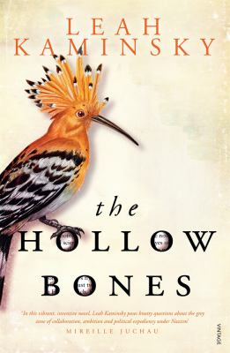
The Hollow Bones by Leah Kaminsky

Synopsis
Berlin, 1936. Ernst Schäfer, a young, ambitious zoologist and keen hunter and collector, has come to the attention of Heinrich Himmler, who invites him to lead a group of SS scientists to the frozen mountains of Tibet. Their secret mission: to search for the origins of the Aryan race. Ernst has doubts initially, but soon seizes the opportunity to rise through the ranks of the Third Reich.
While Ernst prepares for the trip, he marries Herta, his childhood sweetheart. But Herta, a flautist who refuses to play from the songbook of womanhood and marriage under the Reich, grows increasingly suspicious of Ernst and his expedition.
When Ernst and his colleagues finally leave Germany in 1938, they realise the world has its eyes fixed on the horror they have left behind in their homeland.

Discussion questions
- Leah Kaminsky has utilised some literary tricks in The Hollow Bones such as the cliff-hanger of Herta and the Panda in the Academy of Natural Sciences in Philadelphia. How did you find this effective?
- The ambition and urges of The Collector have been explored in many wonderful works of fiction, from Nicholson Baker to John Fowles, and now Leah Kaminsky. What makes characters with these drives so fascinating?
- The Hollow Bones explores some urgent and contemporary issues including how scientific findings can be manipulated to suit different masters. What happens when the line between science and politics is blurred too far?
- History repeating itself. Have we really learnt from the past? These are statements we hear often. How do you think fiction advances our understanding of the past?
- Why do you think so many novels explore the First and Second World Wars?
- Women are often not the protagonists in fiction or non-fiction stories of the Second World War. How much responsibility do you believe women bore for the machinations of war at the fronts and at home?
- Ernst joined the Reich ostensibly to feed his ambition and achieve great scientific breakthroughs. Do you believe any part of Ernst was pursuing good things for mankind? Would you be prepared to compromise some parts of your belief system to achieve something you believed valuable?

Synopsis/Discussion questions from https://www.penguin.com.au/book-clubs/2169-the-hollow-bones-book-club-notes

