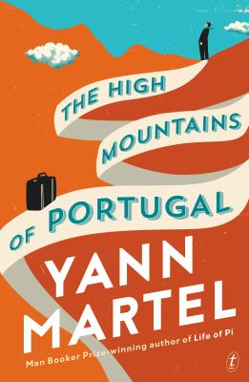
The High Mountains of Portugal by Yann Martel

Synopsis
In Lisbon in 1904, a young man named Tomás discovers an old journal. It hints at the existence of an extraordinary artifact that—if he can find it—would redefine history. Traveling in one of Europe’s earliest automobiles, he sets out in search of this strange treasure.
Thirty-five years later, a Portuguese pathologist devoted to the murder mysteries of Agatha Christie finds himself at the center of a mystery of his own and drawn into the consequences of Tomás’s quest.
Fifty years on, a Canadian senator takes refuge in his ancestral village in northern Portugal, grieving the loss of his beloved wife. But he arrives with an unusual companion: a chimpanzee. And there the century-old quest will come to an unexpected conclusion.

Discussion questions
- The High Mountains of Portugal, as we come to learn, do not contain high mountains. Why do you think Martel chose The High Mountains of Portugal as the title for his novel? In a novel that uses allegory, is there an allegorical meaning to the High Mountains?
- Martel titles the three parts of his novel “Homeless,” “Homeward,” and “Home.” Discuss the role that home plays in the novel and why he might have given the parts these titles.
- In Part Two, Maria Lozora encourages her husband to read the novels of Agatha Christie to bring him closer to the Gospels. How convincing is her description of Agatha Christie’s murder mysteries as being similar to the -Gospels?
- Maria Castro asks Dr. Lozora to perform an autopsy on her husband, but she asks him to tell her not how he died but how he lived. Discuss the objects found in Rafael Castro’s body during the autopsy. What might they represent about how her husband lived? What do you make of the two animals found in Rafael’s chest? Imagine you were the body undergoing the autopsy. What objects might Dr. Lozora find in you?
- Maria also says, “The heart has two choices: to shut down or to open up.” Discuss this statement in terms of how each of the characters in the other parts chooses to live.
- Part One of the novel is a quest, Part Two mixes allegory with magical realism, and Part Three is contemporary realism. Which section of the book are you most drawn to?
- The High Mountains of Portugal is a novel about loss, among other themes. Tomas has lost his young lover and their son; Maria Castro has lost her husband and son; Senator Peter Tovy has lost his wife. Discuss each character’s response to loss. In presenting the three different -stories, what might Martel be trying to tell us about how to live with the loss of a loved one?
- What other themes do you find in the novel—-for example, how important is faith and how important is love in each of the three parts? And which themes resonate for you personally most deeply?
Synopsis/Discussion questions from https://www.penguinrandomhouse.com/books/242201/the-high-mountains-of-portugal-by-yann-martel/9780812987034/readers-guide/

