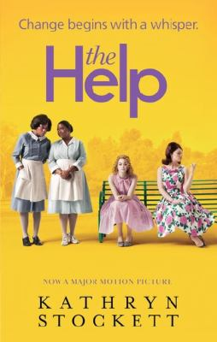
The Help by Kathryn Stockett

Synopsis
Twenty-two-year-old Skeeter has just returned home after graduating from Ole Miss. She may have a degree, but it is 1962, Mississippi, and her mother will not be happy till Skeeter has a ring on her finger. Skeeter would normally find solace with her beloved maid Constantine, the woman who raised her, but Constantine has disappeared and no one will tell Skeeter where she has gone.
Aibileen is a black maid, a wise, regal woman raising her seventeenth white child. Something has shifted inside her after the loss of her own son, who died while his bosses looked the other way. She is devoted to the little girl she looks after, though she knows both their hearts may be broken.
Minny, Aibileen’s best friend, is short, fat, and perhaps the sassiest woman in Mississippi. She can cook like nobody’s business, but she can’t mind her tongue, so she’s lost yet another job. Minny finally finds a position working for someone too new to town to know her reputation. But her new boss has secrets of her own.
Seemingly as different from one another as can be, these women will nonetheless come together for a clandestine project that will put them all at risk. And why? Because they are suffocating within the lines that define their town and their times. And sometimes lines are made to be crossed.

Discussion questions
- Who was your favorite character? Why?
- What do you think motivated Hilly? On the one hand she is terribly cruel to Aibileen and her own help, as well as to Skeeter once she realizes that she can’t control her. Yet she’s a wonderful mother. Do you think that one can be a good mother but, at the same time, a deeply flawed person?
- How much of a person’s character would you say is shaped by the times in which they live?
- Did it bother you that Skeeter is willing to overlook so many of Stuart’s faults so that she can get married, and that it’s not until he literally gets up and walks away that the engagement falls apart?
- Do you believe that Minny was justified in her distrust of white people?
- Do you think that had Aibileen stayed working for Miss Elizabeth, that Mae Mobley would have grown up to be racist like her mother? Do you think racism is inherent, or taught?
- The author manages to paint Aibileen with a quiet grace and an aura of wisdom about her. How do you think she does this?
- Do you think there are still vestiges of racism in relationships where people of color work for people who are white?
- What did you think about Minny’s pie for Miss Hilly? Would you have gone as far as Minny did for revenge?
Synopsis/Discussion questions from https://www.litlovers.com/reading-guides/13-reading-guides/fiction/423-the-help-stockett?showall=1

