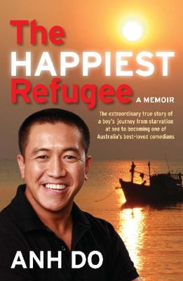
The Happiest Refugee by Anh Do

Synopsis
Anh Do nearly didn't make it to Australia. His entire family came close to losing their lives on the sea as they escaped from war-torn Vietnam in an overcrowded boat. But nothing - not murderous pirates, nor the imminent threat of death by hunger, disease or dehydration as they drifted for days - could quench their desire to make a better life in the country they had dreamed about.
Life in Australia was hard, an endless succession of back-breaking work, crowded rooms, ruthless landlords and make-do everything. But there was a loving extended family, and always friends and play and something to laugh about for Anh, his brother Khoa and their sister Tram. Things got harder when their father left home when Anh was only nine - they felt his loss very deeply and their mother struggled to support the family on her own.
His mother's sacrifice was an inspiration to Anh and he worked hard during his teenage years to help her make ends meet, also managing to graduate high school and then university. Another inspiration was the comedian Anh met when he was about to sign on for a 60-hour a week corporate job. Anh asked how many hours he worked. 'Four,' the answer came back, and that was it. He was going to be a comedian!
The Happiest Refugee tells the incredible, uplifting and inspiring life story of one of our favourite personalities. Tragedy, humour, heartache and unswerving determination - a big life with big dreams. Anh's story will move and amuse all who read it.

Discussion questions
- Did you know of Anh Do before reading the book? Did you know his history? Did reading the book change your opinion of him?
- What do you think about the Vietnam custom of giving numbers to children for nicknames?
- Anh’s Dad said, “Always question fear... there’s almost never a good reason to be scared.” What does he mean by ‘questioning’ fear? How could his relate to your life?
- What did Anh give up to pursue his ambition of becoming a standup comedian? What motivated him?
- Anh places us, his readers, in a privileged position, a god-like or omniscient position. We watch the events and can also hear Anh’s inner thoughts, like asides in a Shakespearean play. How does this technique make Anh’s writing intriguing for his audience?
- On page 150, we are taken back to the incident that starts Anh’s memoir the confrontation with his father after eight years of no communication between the two. What lines are repeated from the prologue? Why does he return to this episode at this point in his memoir? What effect does this structural choice have on you as a reader?
- The chapter finishes with Anh and his family on a boat on a river at Bobbin Head National Park. Why has Anh done this? What is its significance?
- Has your insight into refugee experiences been enhanced (improved) by the book?

