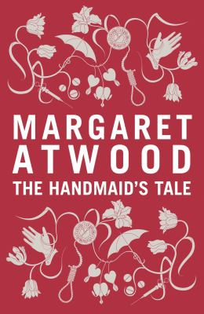
The Handmaid’s Tale by Margaret Atwood

Synopsis
Everything Handmaids wear is red: the colour of blood, which defines us." Offred is a Handmaid in the Republic of Gilead, where women are prohibited from holding jobs, reading, and forming friendships.
She serves in the household of the Commander and his wife, and under the new social order she has only one purpose: once a month, she must lie on her back and pray that the Commander makes her pregnant, ecause in an age of declining births, Offred and the other Handmaids are valued only if they are fertile. But Offred remembers the years before Gilead, when she was an independent woman who had a job, a family, and a name of her own.
Now, her memories and her will to survive are acts of rebellion.

Discussion questions
- Of The Handmaid’s Tale, Margaret Atwood has said, ‘One of my rules was that I would not put any events into the book that had not already happened in what James Joyce called the “nightmare” of history, nor any technology not already available. No imaginary gizmos, no imaginary laws, no imaginary atrocities.’ What do you think is the effect of this?
- Higher-class members of society are given names but even those don’t appear to be their real ones. Handmaids are expressly forbidden to be called by their names and are instead named after the Commanders who own them. What does the changing of names achieve in Gilead society? Why do you think Offred tells Nick her old name?
- Throughout The Handmaid’s Tale, Offred wistfully recalls things from her past that are now banned under Gilead rule. Of course, the biggest loss of all is her freedom and her family. But forbidden objects from everyday life also take on a powerful new meaning. What do they represent and how do they create distinctions between the characters?
- In The Handmaid’s Tale, all the characters have an assigned role – Wife, Handmaid, Commander, Angel, Martha, Aunt. Moira is an exception to this. Talk about the role of her character in the novel.
- In 2017 The Handmaid’s Tale was adapted for TV, and subsequent series that extend beyond the novel have been produced. Have you watched the TV adaptation? What do you think of the interpretation, and which do you prefer? Why?
- Did the Historical Notes section change your reading of the novel? How and why?
- The Handmaid’s Tale was first published in 1985, yet in recent years it has returned to the bestseller charts and women around the world have donned Handmaid costumes to attend protests against the rolling back of women’s rights. Why do you think the story of Gilead is still so relevant today?
Synopsis/Discussion questions from https://www.penguin.com.au/book-clubs/2463-the-handmaids-tale-book-club-notes

