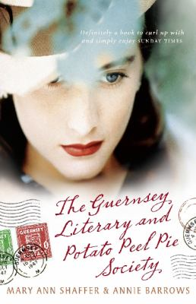
The Guernsey Literary and Potato Peel Pie Society by Mary Ann Shaffer and Annie Barrows

Synopsis
January 1946: London is emerging from the shadow of the Second World War, and writer Juliet Ashton is looking for her next book subject. Who could imagine that she would find it in a letter from a man she’s never met, a native of the island of Guernsey, who has come across her name written inside a book by Charles Lamb.
As Juliet and her new correspondent exchange letters, Juliet is drawn into the world of this man and his friends. ‘The Guernsey Literary and Potato Peel Pie Society’ - born as a spur-of-the-moment alibi when its members were discovered breaking curfew by the Germans occupying their island - boasts a charming, funny, deeply human cast of characters, from pig farmers to phrenologists, literature lovers all.
Juliet begins a remarkable correspondence with the society’s members, learning about their island, their taste in books, and the impact the recent German occupation has had on their lives. Captivated by their stories, she sets sail for Guernsey, and what she finds will change her forever.

Discussion questions
- What was it like to read a novel composed entirely of letters? What do letters offer that no other form of writing (not even emails) can convey?
- What makes Sidney and Sophie ideal friends for Juliet? What common ground do they share? Who has been a similar advocate in your life?
- Discuss the poets, novelists, biographers and other writers who capture the hearts of the members of the Guernsey Literary and Potato Peel Pie Society. What does a reader’s taste in books say about his or her personality? Whose lives were changed the most by membership in the society?
- In what ways were Juliet and Elizabeth kindred spirits? What did Elizabeth’s spontaneous invention of the society, as well as her brave final act, say about her approach to life?
- Kit and Juliet complete each other in many ways. What did they need from each other? What qualities make Juliet an unconventional, excellent mother?
- How did Remy’s presence enhance the lives of those on Guernsey? Through her survival, what recollections, hopes and lessons also survived?
- What historical facts about life in England during World War II were you especially surprised to discover? What traits, such as remarkable stamina, are captured in a detail such as potato peel pie? In what ways does fiction provide a means for more fully understanding a nonfiction truth?
- Which of the members of the Society is your favourite? Whose literary opinions are most like your own? Do you agree with Isola that “reading good books ruins you for enjoying bad ones”?
Synopsis/Discussion questions from https://www.readinggroupguides.com/reviews/the-guernsey-literary-and-potato-peel-pie-society/guide

