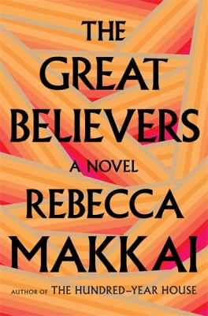
The Great Believers by Rebecca Makkai

Synopsis
In 1985, Yale Tishman is the development director at the art gallery at Northwestern University, working to bring in an extraordinary collection of 1920s paintings as a gift from an elderly woman who was once an artist’s model in Paris. Yet as his career begins to flourish, the carnage of the AIDS epidemic grows around him. The novel opens on the funeral day of his late friend Nico. As the virus continues to take its toll on the gay community in Chicago, Yale grows closer to Nico’s little sister Fiona, who comes to care for many of Nico’s friends.
Thirty years later, Fiona is in Paris tracking down her estranged daughter Claire who disappeared into a cult. While staying with her old friend Richard, a famous photographer who documented the Chicago epidemic, she finds herself surrounded by memories and reminders of that time. Finally, she begins to understand just how profoundly the AIDS crisis affected her life, grappling with what she sacrificed in caring for and loving these men, sacrifices that affected her marriage and her relationship with her daughter. Yale and Fiona’s stories unfold in moving and sometimes surprising ways, as both struggle to find goodness and feel hope in the face of disaster.

Discussion questions
- Yale’s group of friends is very close. In a sense, they are his “chosen family.” How is this explored in the book? How does each character relate to their family, biological and chosen? Do you have a “chosen family,” and if so, what brings you all together?
- How has the culture changed regarding LGBTQ+ voices and stories since the 1980s?
- Chicago is such a powerful presence in this novel that it is almost a character in itself. Have you ever been to or lived in a place that exerted a strong influence on you?
- Nora, the elderly woman donating the 1920s pieces, seems completely removed from the rest of Yale’s life, yet her story contains elements that can be compared and contrasted with Yale’s. What similarities between his and her life are there? How has her past affected the present?
- Fiona has suffered many losses in her life. How do you think that affected her as a mother? What are the ways in which trauma and loss are passed down through generations?
- Do you empathize more with Fiona or Claire?
- On page 353, Asher asks Yale, “Does it really ever go anywhere? . . . Love. Does it vanish?” Yale replies, “I mean, we never want it to. But it does, doesn’t it?” What would you say to them?
- Is the creation of artwork always a collaborative effort? How do you feel about the relationship between artist and muse?
Synopsis/Discussion questions from https://www.penguinrandomhouse.com/books/553185/the-great-believers-by-rebecca-makkai/9780735223530/readers-guide/

