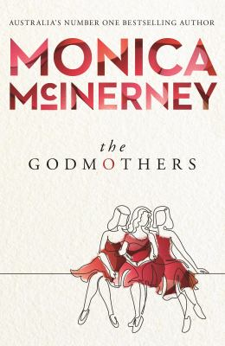
The Godmothers by Monica McInerney

Synopsis
The highly anticipated new family drama from one of Australia's most beloved authors.
Eliza Miller grew up in Australia as the only daughter of a troubled young mother, but with the constant support of two watchful godmothers, Olivia and Maxie. Despite her tricky childhood, she always felt loved and secure. Until, just before her eighteenth birthday, a tragic event changed her life.
Thirteen years on, Eliza is deliberately living as safely as possible, avoiding close relationships and devoting herself to her job. Out of the blue, an enticing invitation from one of her godmothers prompts a leap into the unknown.
Within a fortnight, Eliza finds herself in the middle of a complicated family in Edinburgh. There’s no such thing as an ordinary day any more. Yet, amidst the chaos, Eliza begins to blossom. She finds herself not only hopeful about the future, but ready to explore her past, including the biggest mystery of all – who is her father?
Set in Australia, Scotland, Ireland and England, THE GODMOTHERS is a great big hug of a book that will fill your heart to bursting. It is a moving and perceptive story about love, lies, hope and sorrow, about the families we are born into and the families we make for ourselves.

Discussion questions
- In what ways are Maxie and Olivia the opposite of ‘wishy-washy’ godmothers?
- Eliza says there isn’t a ‘label’ for Sullivan, but what is it about him that makes him special, do you think?
- Despite their best intentions, do you think it was right for Olivia and Maxie to withhold the truth about Jeannie from Eliza for all those years? What would you have done in the same situation?
- Eliza, too, has coping strategies for dealing with the loss of her loved one, by bringing out the ‘jukebox of Jeannie tales, her playlist of happy memories’. What other ways might people handle the pain of losing a beloved family member to death or dementia?
- Can a godmother be any sort of replacement for a real mother?
- Can godchildren replace children in a woman’s life, as in Olivia and Maxie’s case with Eliza?
- Jeannie had never wanted a conventional life for herself or for her daughter. Do you think she would be happy with how things turned out for Eliza?
- Emmet believes that ‘family life is sometimes more about pretending to get on than actually getting on’. Discuss.
Discussion questions from https://www.penguin.com.au/book-clubs/2835-the-godmothers-book-club-notes

