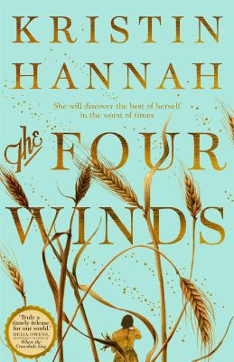
The Four winds by Kristin Hannah

Synopsis
Texas, 1921. A time of abundance. The Great War is over, the bounty of the land is plentiful, and America is on the brink of a new and optimistic era. But for Elsa Wolcott, deemed too old to marry in a time when marriage is a woman’s only option, the future seems bleak. Until the night she meets Rafe Martinelli and decides to change the direction of her life. With her reputation in ruin, there is only one respectable choice: marriage to a man she barely knows. By 1934, the world has changed. Millions are out of work, and drought has devastated the Great Plains. Farmers are fighting to keep their land and their livelihoods as crops fail, water dries up and the earth cracks open. Dust storms roll relentlessly across the plains. Everything on the Martinelli farm is dying, including Elsa’s tenuous marriage; each day is a desperate battle against nature and a fight to keep her children alive.
In this uncertain and perilous time, Elsa --- like so many of her neighbors --- must make an agonizing choice: fight for the land she loves, or leave it behind and go west, to California, in search of a better life for her family.

Discussion questions
- ‘She wished she’d never read The Age of Innocence. What good came from all this unexpressed longing? She would never fall in love, never have a child of her own.’ (8) Literature is, quite honestly, the opening of a door. Through that door, Elsa saw whole other lives, other futures. What books influenced you when you were growing up?
- Motherhood changes Elsa in almost every way. What does she learn by becoming a mother? What does she learn about motherhood from Rose? How does motherhood strengthen a woman? How does it weaken her? How does Elsa remain ‘herself’ after giving birth? How does she change?
- There is a strong thread running through this novel about man’s connection to the land. During the Dust Bowl, while many families went west in search of work and a better life, most of them stayed behind on their parched farms. Why do you think that is?
- What do you think about Rafe? Was he as trapped by his family’s expectations as Elsa had been by her own? Did you expect him to leave?
- ‘They’d sewn their lives together in the silent way of women unused to conversation. Day after day, they worked together, prayed together, held their growing family together through the hardships of farm life.’ (90,91) Why do you think female bonding is so important to women?
- Why does Rafe leave, and what is he chasing out west? Do you have sympathy for how broken he felt by the poverty and hardship? Should Elsa have agreed to go with him?
- ‘Courage is fear you ignore.’ Discuss this. How do Elsa’s and Loreda’s actions embody this idea?
- Did you find the end of Elsa’s and her family’s journey satisfying? Where do you think Ant and Loreda ended up? How do you see Loreda’s life being like her mother’s? How will it be different?
Synopsis/Discussion questions from https://www.readinggroupguides.com/reviews/the-four-winds/guide

