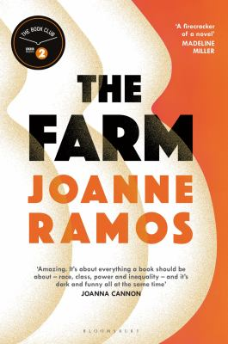
The Farm by Joanne Ramos

Synopsis
Nestled in New York’s Hudson Valley is a luxury retreat boasting every amenity: organic meals, personal fitness trainers, daily massages—and all of it for free. In fact, you’re paid big money to stay here—more than you’ve ever dreamed of. The catch? For nine months, you cannot leave the grounds, your movements are monitored, and you are cut off from your former life while you dedicate yourself to the task of producing the perfect baby. For someone else.
Jane, an immigrant from the Philippines, is in desperate search of a better future when she commits to being a “Host” at Golden Oaks—or the Farm, as residents call it. But now pregnant, fragile, consumed with worry for her family, Jane is determined to reconnect with her life outside. Yet she cannot leave the Farm or she will lose the life-changing fee she’ll receive on the delivery of her child.

Discussion questions
- Does it seem like a place like Golden Oaks could exist now or in the near future? Could you see yourself applying to be a Host or using Golden Oaks’ services? Why or why not?
- Reagan and Jane come from very different worlds, yet end up being close friends. How are their experiences and viewpoints similar, and how do they differ? Why do you think they formed such a close bond? What does each of them offer to the other?
- Were you surprised by Jane’s decision to run away from Golden Oaks? How does this represent a transformation in her character?
- What did you think of Jane’s choice to work for Mae after leaving Golden Oaks? How do you think this decision relates to the agency she gains throughout the novel? Considering all the factors at play in Jane’s life, do you think she made the right decision? What would you have done in her place?
- Mae Yu and Ate are both characters who seem to exemplify the ambition and entrepreneurial spirit of the proverbial American Dream. What are their motivations, and how are they similar? What do the ways they choose to achieve their goals say about them as characters?
- One of the major themes in The Farm is the relationship between luck and merit in individual lives. How does this play out among the four main characters in the novel? How do these two forces of luck and merit affect the agency that the characters in the novel have?
- While this novel is about four women, ultimately it is still a white man, Leon, who holds the power. What do you think this says about the world of the novel, and about Golden Oaks in particular?
- Towards the end of the book, Reagan is saddened when contemplating the lives of Jane and Ate, because she feels nothing will change—for them or for their children. However, Jane, at the very end of the novel, expresses hope that the future might be different. Have things changed for these characters? What, if anything, hasn’t changed? Who believes in change, and why?

Synopsis/Discussion questions from http://www.randomhousebooks.com/articles/book-club-resources/

