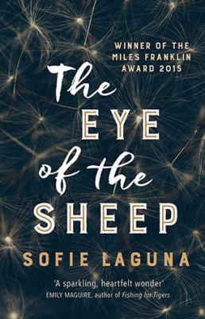
The Eye of the Sheep by Sofie Laguna

Synopsis
Ned was beside me, his messages running easily through him, with space between each one, coming through him like water. He was the go-between, going between the animal kingdom and this one. I watched the waves as they rolled and crashed towards us, one after another, never stopping, always changing. I knew what was making them come, I had been there and I would always know.
Meet Jimmy Flick. He’s not like other kids - he’s both too fast and too slow. He sees too much, and too little. Jimmy’s mother Paula is the only one who can manage him. She teaches him how to count sheep so that he can fall asleep.
She holds him tight enough to stop his cells spinning. It is only Paula who can keep Jimmy out of his father’s way. But when Jimmy’s world falls apart, he has to navigate the unfathomable world on his own, and make things right.

Discussion questions
- How does Jimmy’s fascination with the mechanics of things help him understand his world?
- Why do you think Robby had to leave?
- Throughout the book, many of the characters struggle with feelings of shame. How does shame affect their perception of themselves, their relationships with others, the choices they make?
- What do you think Jimmy means by the ‘invisible world’?
- Consider the holiday that Gavin and Jimmy take to the island. What impact does this have on their relationship?
- ‘If he said one word, even one, the word made a space for the thing he didn’t like or want to come crashing in and detonate him. It was the words that made the opening.’ (p.26) Consider the ways in which Robby, Gavin, Jimmy and Paula all invoke silence as a means of coping. What is it that is not being said?
- How does Jimmy use the visual of ‘lines’ to understand the relationships with and within his family? Where do these lines lead him?
- ‘The only place for me was in the water, in the light, with my mum where I had begun and where I ended.’ (p.300) Discuss the ways in which the recurring motif of water becomes significant throughout the book. In particular, discuss the power of water for Jimmy in the final section of the book.
- What does Jimmy see in the eye of the sheep?

Synopsis/Discussion questions from https://www.allenandunwin.com/browse/book/Sofie-Laguna-Eye-of-the-Sheep-9781760292799

