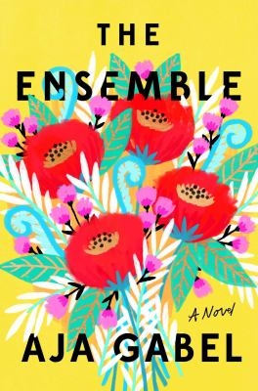
The Ensemble by Aja Gabel

Synopsis
Jana. Brit. Daniel. Henry. They would never have been friends if they hadn’t needed each other. They would never have found each other except for the art which drew them together. They would never have become family without their love for the music, for each other.
Brit is the second violinist, a beautiful and quiet orphan; on the viola is Henry, a prodigy who’s always had it easy; the cellist is Daniel, the oldest and an angry skeptic who sleeps around; and on first violin is Jana, their flinty, resilient leader. Together, they are the Van Ness Quartet. After the group’s youthful, rocky start, they experience devastating failure and wild success, heartbreak and marriage, triumph and loss, betrayal and enduring loyalty. They are always tied to each other – by career, by the intensity of their art, by the secrets they carry, by choosing each other over and over again.

Discussion questions
- How did the personal dynamics of the ensemble play out through their performances?
- How do you think the characters approach ambition and creativity?
- Who was your favourite character and why? Who was your least favourite? All of the characters pair up at some point and have their own scene together—which was your favourite pairing?
- Do you think this novel is a love story (echoing the opening section), and in what ways?
- What were the strengths and weaknesses in having each character’s voice present in the narrative? What does that reveal? What gets in the way? Was one character more forthcoming than the others? Was there one who you kept wishing you could stay with?
- Was anything surprising to you about the life of working musicians? How was it different or expected than what you previously thought?
- What did you think of Kimiko having her own chapter?
- How do you think the writing reflects musical quality and structure, if at all?
- Passion is a theme that runs throughout the novel—how do you see that manifesting?

Synopsis/Discussion questions from https://www.penguinrandomhouse.com/books/550847/the-ensemble-by-aja-gabel/

