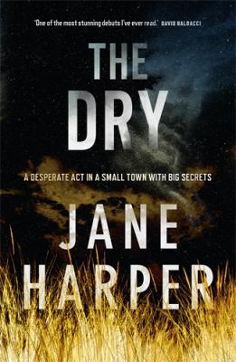
The Dry by Jane Harper

Synopsis
Severe drought has plagued the small town of Kiewarra in remote country Victoria for two years, and the township is dying. When Luke Hadler, a local farmer, shoots his wife and son in cold blood and then commits suicide, the town is horrified but not especially surprised. There is no one in Kiewarra who has not been affected by the relentless drought. But Luke’s parents, and local police sergeant Greg Raco, have doubts. Why would Luke kill his son but allow his thirteen-month-old daughter to live?
Aaron Falk, Luke’s childhood friend and a police officer himself, has not been back to Kiewarra since he left nearly twenty years ago following the death of sixteen year-old Ellie Deacon. Falsely accused of being involved and subjected to continual harassment by Ellie’s father and cousin, Falk and his father Erik moved to Melbourne, cutting all ties with their home town. But returning to Kiewarra for Luke’s funeral re-opens old wounds, both for Falk and for Ellie’s relatives.
Persuaded to stay in town to look into the Hadlers’ deaths, Falk once again becomes the target of abuse for his long-ago association with Ellie Deacon. Zeroing in on Ellie’s father Mal and cousin Grant, Falk begins to suspect a link between Ellie’s death and the Hadlers’. Or is he simply blinded by the need to see Mal and Grant punished? As he re-lives the painful events of the past, Falk begins to come to different conclusions about both cases – and realises that all along he has been backing the wrong horse.

Discussion questions
- What is it about the drought and its effects on the town that makes people less likely to question what happened to the Hadlers?
- Why do you think Gretchen is so reluctant to tell Falk who Lachie’s real father is? Who do you think it is?
- Do you think that leaving town was the right way for Erik Falk to deal with the situation he and Aaron were facing? How did his father’s doubts about him affect Aaron?
- In spite of their shared childhood, Luke and Falk had very different personalities. What is it that spells the end of their friendship? Do you think they would have remained friends if they hadn’t lied about where they were at the time of Ellie’s death, and/or if Luke had told Aaron where he really was in the first place?
- How does the town itself inform our ideas about the people who live there and the events that take place there? What are the positives and negatives of a small town’s tight-knit community?
- The bush, the rock tree and the Kiewarra River are the scenes of several major events in the novel. Why do you think Aaron is drawn to these places? What does the contrast between the wild places in the novel and those tamed by human habitation show us?
- The novel begins with a prologue that describes flies being drawn to the scene of the murders. Why is this approach such a powerful way to introduce the events of the novel?
Synopsis/Discussion questions from https://www.panmacmillan.com.au/9781925481372/

