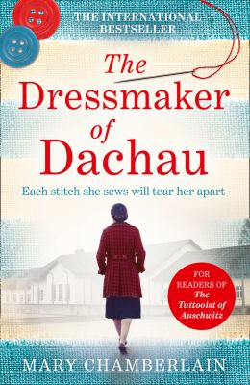
The Dressmaker of Dachau by Mary Chamberlain

Synopsis
Spring 1939. Taken prisoner by the Nazis, eighteen-year-old Ada is forced into a life of slavery and horror in Dachau concentration camp.
Her skill as a seamstress is the only bargaining chip she has against the brutal SS guards. Back in London, she dreamed of being a world-renowned designer; now she must sew to save her life…but at what cost?

Discussion questions
- When Stanislaus appears, near the beginning of the story, Ada falls for him almost instantly. Why do you think she is so susceptible to his charm? What are some of the possibilities that Stanislaus represents, to Ada? Is she changed by him, and if so, how?
- Ada describes her employer, Mrs. Buckley, as someone who is “crafted through artifice.” Throughout the story, there are many instances of people attempting to look like something they are not; people changing their appearances. What are some of these instances, both good and bad? How does dressmaking, and clothing in general, relate to this theme?
- Why do you think Ada ignores the warnings of war, when Stanislaus invites her to Paris? How might her life have turned out differently, if she hadn’t gone?
- During Ada’s trial, near the end of the book, the question of Ada’s sanity during wartime starts to come into question. How much of Ada’s decision-making in wartime seemed like a rational choice to stay alive? Did any of her choices seem irrational, in the moment? If you had been in the same situation as Ada, during the war, what would you have done the same, or differently?
- How does hope keep Ada going, throughout the story? What are some of the ways that she remains hopeful, even in the darkest times?
- After the war, Ada becomes, in effect, a prostitute, operating beyond acceptable social and sexual mores. What part does this play in her downfall? How do we see double standards—one law for women, one for men—at play in the way she is treated?
- At the end of the story, Ada’s version of events clashes with the prosecutor’s version. She observes how the facts can be twisted, but wonders where is the in-between: “the truth, that connected one fact to another.” What are some instances where you’ve seen this happen in real life, where two narratives are spun from the same set of facts? The jury ultimately accepted the prosecutor’s narrative, not Ada’s. Why do you think some narratives are more acceptable than others?
- There are many novels and stories now set in World War I and World War II. Why do you think stories of war endure? Is there something about a war that reveals the strengths and frailties of human beings? How have stories of war—the way we write, talk, and think about them—changed over time?
Discussion questions from https://marychamberlainbooks.com/2016/03/09/discussion-questions/

