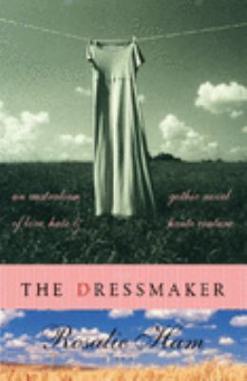
The Dressmaker by Rosalie Ham

Synopsis
After twenty years spent mastering the art of dressmaking at couture houses in Paris, Tilly Dunnage returns to the small Australian town she was banished from as a child. She plans only to check on her ailing mother and leave. But Tilly decides to stay, and though she is still an outcast, her lush, exquisite dresses prove irresistible to the prim women of Dungatar.
Through her fashion business, her friendship with Sergeant Farrat—the town’s only policeman, who harbors an unusual passion for fabrics—and a budding romance with Teddy, the local football star whose family is almost as reviled as hers, she finds a measure of grudging acceptance.
But as her dresses begin to arouse competition and envy in town, causing old resentments to surface, it becomes clear that Tilly’s mind is set on a darker design: exacting revenge on those who wronged her, in the most spectacular fashion.

Discussion questions
- What makes The Dressmaker a gothic novel?
- Why does Tilly make clothes for the women of Dungatar?
- Why is Teddy McSwiney the town hero?

- The residents of Dungatar are narrow minded and hypocritical. They sweep their footpaths and hose their windows to hide the indecent aspects of their own lives. Do you agree?
- Each part of The Dressmaker is prefaced by a description of a type of fabric. Why do you think Rosalie Ham uses these definitions at the start of each part?
- What moments of The Dressmaker do you find funny?
- Tilly’s grief and outrage after the death of Teddy and her mother propel her along the same path as her mother. Her bitterness festers but it is disciplined by an iron will that allows Tilly to wreak a havoc that provides a satisfying revenge. Do you think the actions of her revenge were deserved?
- There is now a sequel to this title – The Dressmaker’s Secret. Will you read it?

