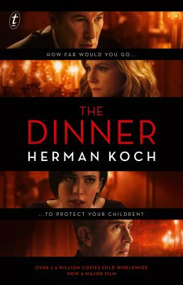
The Dinner by Herman Koch

Synopsis
It’s a summer’s evening in Amsterdam, and two couples meet at a fashionable restaurant for dinner. Between mouthfuls of food and over the scrapings of cutlery, the conversation remains a gentle hum of polite discourse. But behind the empty words, terrible things need to be said, and with every forced smile and every new course, the knives are being sharpened.
Each couple has a fifteen-year-old son. The two boys are united by their accountability for a single horrific act—an act that has triggered a police investigation and shattered the comfortable, insulated worlds of their families. As the dinner reaches its culinary climax, the conversation finally touches on their children, and as civility and friendship disintegrate, each couple shows just how far they are prepared to go to protect those they love.

Discussion questions
- How did your opinion of Paul and Serge shift throughout the novel? How might the story line have unfolded if it had been told from a mother’s point of view?
- In what way do the courses of a meal—from aperitif to digestif—echo the experience of savoring a suspenseful novel? As the waiter described each delicacy in The Dinner, did the food appeal to you, or did you share Paul’s belief that it was pretentious?
- What do you think of the sympathy Paul and Claire feel for their son? As a parent, how far would you go to defend your child?
- Do Michel and Rick represent the indifference of their generation, or are teenagers more socially conscious in the Information Age?
- How much influence do Claire and Babette have over their husbands? How do they define good mothering?
- The novel opens with Paul’s commentary on how much Serge irritates him. What accounts for their attitude toward each other? Does Paul’s animosity run deeper than typical sibling rivalry?
- Ultimately, who is to blame for the homeless woman’s death? What does the novel indicate about the responsibilities (or irresponsibility)of the upper class?
- What does the story of cousins Michel and Rick say about nature versus nurture? How do you think Beau/Faso sees his adoptive family? What have they taught him about getting ahead?
- How did you react to Claire and Michel’s “solution”?
- What commentary does the novel offer about the author’s homeland? What aspects of The Dinner would change if it were set in Washington, D.C., rather than in the Netherlands?
Synopsis/Discussion questions from https://www.penguinrandomhouse.com/books/221991/the-dinner-by-herman-koch/

