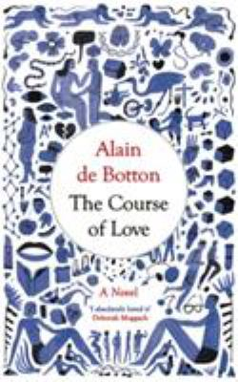
The Course of Love by Alain de Botton

Synopsis
We all know the headiness and excitement of the early days of love. But what comes after? In Edinburgh, a couple, Rabih and Kirsten, fall in love. They get married, they have children—but no long-term relationship is as simple as "happily ever after."
The Course of Love is a novel that explores what happens after the birth of love, what it takes to maintain love, and what happens to our original ideals under the pressures of an average existence. You experience, along with Rabih and Kirsten, the first flush of infatuation, the effortlessness of falling into romantic love, and the course of life thereafter.
Interwoven with their story and its challenges is an overlay of philosophy—an annotation and a guide to what we are reading.

Discussion questions
- What makes this book distinctive?
- What is the difference between Rabih and Kirsten's views of love at the start and at the end of the story?
- What does the author mean by 'Romanticism' throughout the book?
- In what way is Rabih hard to live with?
- In what way is Kirsten hard to live with?
- What do the characters gradually learn about one another?
- Can a good novel be didactic? If not, why not?
- Does the division into action and italicized commentary work?
- What are the immature patterns of behavior that make love hard for our couple?
- What is mature love?

Discussion questions from https://www.bookbrowse.com/reading_guides/detail/index.cfm/book_number/3505/the-course-of-love

