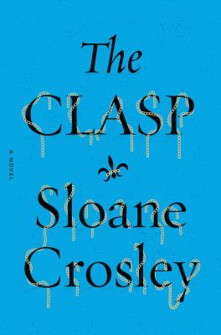
The Clasp by Sloane Crosley

Synopsis
THE CLASP opens on a private island in Florida, as three hapless 20-somethings gather for their friends’ wedding. For Kezia, the trip fails to deliver a break from her boss from hell, a jewelry designer in Manhattan. Nathaniel was a literary cool kid but now struggles to get Hollywood backing for his brainchild: a television show called “The Pretenders.” Victor was just fired from his job at a mediocre search engine, but his fortune --- and the fate of his friends --- changes dramatically when he begins snooping around and, in a drunken stupor, passes out in the groom’s mother’s bed. She slaps him awake, but instead of scolding him, she tells him an enticing secret about a valuable necklace that disappeared during the Nazi occupation of France.
Embarking on a madcap treasure hunt that leads from New York to Paris, with an excursion to the chateau where Maupassant was born, the trio struggles to interpret cryptic clues while separating fakes from the real thing --- not only in the world of gems, but also in life and love.

Discussion questions
- Discuss the Yeats and Maupassant epigraphs. Which of the novel’s characters do they capture the best?
- What first impressions did you get of Kezia, Victor and Nathaniel as they gathered in Florida for the wedding? As the scenes shifted in points of view, who were you rooting for the most?
- Johanna tells Victor that she doesn’t want Felix to know about the necklace because ‘he’s very sensitive about anything having to do with Nazi heritage’ and because it might not still be where the soldier hid it. Do you think it’s that simple, or was Johanna up to something else when she decided to entrust a stranger with her secret?
- What were your theories about the drawing? What results did you predict for the treasure hunt? Make a virtual visit to Chateau Miromesnil and imagine what other hidden surprises such a place could hold.
- What does THE CLASP say about the nature of friendship? What has kept Victor, Nathaniel and Kezia from achieving success in their careers as they approach age 30? What do you predict for the next decade of their lives?
- Johanna tells Victor that jewelry is ‘a blank canvas that gets filled by the person who wears it.’ Is there a piece of jewelry in your life that has special significance for you? Do you care whether jewelry is made from precious gems, or is all jewelry ‘real’ in your eyes? Would you value fake jewelry inspired by fictional stories?
- Discuss the idea of a clasp, which is meant to provide security. What does Claude teach Kezia about the practical aspects of his craft? What do all of the characters discover about weak links and ways of strengthening them?
- In the closing scene, on the flight home, have the characters been transformed, or are they simply able to be themselves at last?
Synopsis/Discussion questions from https://www.readinggroupguides.com/reviews/the-clasp/guide

