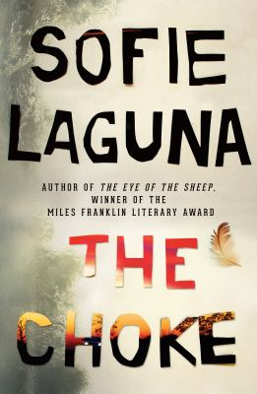
The Choke by Sofie Laguna

Synopsis
I never had words to ask anybody the questions, so I never had the answers. Abandoned by her mother and only occasionally visited by her secretive father, Justine is raised by her pop, a man tormented by visions of the Burma Railway. Justine finds sanctuary in Pop’s chooks and The Choke, where the banks of the Murray River are so narrow it seems they might touch—a place of staggering natural beauty.
But the river can’t protect Justine from danger. Her father is a criminal, and the world he exposes her to can be lethal. Justine is overlooked and underestimated, a shy and often silent observer of her chaotic world. She learns that she has to make sense of it on her own. She has to find ways to survive so much neglect. She must hang on to friendship when it comes, she must hide when she has to, and ultimately she must fight back.

Discussion questions
- As the story’s narrator, Justine refers to her father interchangeably as Dad and Ray. How does this reflect their relationship?
- What is the significance of the Choke to Justine both as a landscape and as a concept?
- Michael’s physical disability means that his mental abilities are not recognised at school. Why do you think Justine is able to relate to him more than the other students?
- What role does Pop play in both keeping the family together, and tearing them apart?
- Justine states, ‘I didn’t know things, but I did know them’ (p. 294) and ‘As if, at the same time as knowing, I didn’t know.’ (p. 314) Do you think Justine is naïve or perceptive?
- ‘Stacey Worlley asked for it a thousand times, then the one time she didn’t.’ (p.232) Do you believe Pop thinks Stacey is partly responsible for Ray’s assault? Is this indicative of the world of masculine power in which Justine lives?
- ‘It was as if the room had left the hospital and was just a room on its own, not part of Yolamundi or Geelong, not belonging to anywhere, just a room with me inside it in a battle.’ (p. 319) How does Justine’s experience of giving birth reflect her life experience? Do you think Justine is alone in the world?
- Pop’s chickens provided a sense of comfort, calm and certainty to Justine. Why do you think she ends their lives so violently?
- The Choke presents us with a disadvantaged child enduring often terrible circumstances, but ends on a note of optimism. How important do you think this optimism is to the success of the story?
- ‘I never had words to ask anybody the questions, so I never had the answers.’ Do you think Justine finds her voice by the end of the novel?
Synopsis/Discussion questions from https://www.allenandunwin.com/browse/books/fiction/The-Choke-Sofie-Laguna-9781760529949

