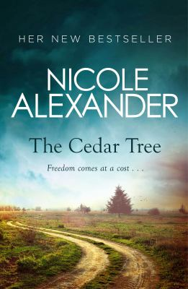
The Cedar Tree by Nicole Alexander

Synopsis
In the spring of 1949, Stella O’Riain flees her home – a sheep property on the barren edge of the Strzelecki Desert. She leaves behind the graves of her husband Joe and her baby daughter.
With no money and limited options, Stella accepts her brother-in-law Harry’s offer to live at the O’Riain cane farm in the Richmond Valley. There she hopes to get answers to the questions that plague her about her marriage. However Harry refuses to discuss Joe or the family’s secrets, even forbidding her to speak to the owner of the neighbouring property.
Nearly a century earlier in County Tipperary, Irish cousins Brandon and Sean O’Riain also fled their homes – as wanted criminals. By 1867, they are working as cedar-cutters in New South Wales’s lush green Richmond Valley.
But while Brandon embraces the opportunities this new country offers, Sean refuses to let go of the past. And one cousin is about to make a dangerous choice that will have devastating consequences down the generations . . .

Discussion questions
- Alternating between the 1860s and the 1940s, among the lush forests of the Richmond Valley and the barren Strzelecki Desert, The Cedar Tree asks whether we can ever truly begin again or if our actions mark us forever? Discuss.
- The Cedar Tree is a captivating tale of love, betrayal, religious intolerance and the far-reaching effects of ambition. Which of these themes struck you the most while reading the novel?
- Maggie and Stella are born in different centuries and yet find their lives changed by the actions of men. Over time, both women take control of their destinies. Discuss and compare their situations. Do you applaud Stella by the end of the novel? Do you have the same admiration for the choices Maggie makes?
- Joe’s personality alters, as does Stella’s, during their marriage. How much of an effect do you feel the environment has on them individually and as a couple?
- The Cedar Tree explores how an individual’s actions can affect people’s lives, even when decades lie between them. Discuss Harry’s attitude towards his brother, Joe, and Brandon and Stella. Is it natural that he stands by his father’s grudges, or should he have made an effort to reconcile sooner?
- The 1860s section of The Cedar Tree is set during a volatile time in Australian history – the continuing decimation of the Big Scrub, and the ramifications of Robertson’s Land Acts. Do you feel that the historical threads running through the narrative were handled deftly?
- The Australian landscape, particularly the Strzelecki Desert, is an integral part of The Cedar Tree. How well has the author managed to convey a sense of place in the novel?

Discussion questions from https://www.penguin.com.au/book-clubs/2530-the-cedar-tree-book-club-notes

