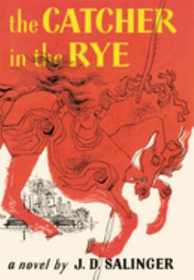
The Catcher in the Rye by J.D. Salinger

Synopsis
The Catcher in the Rye covers 48 hours in the life of 16-year-old Holden Caulfield, who has just flunked out of his expensive boarding school in eastern Pennsylvania.
This makes the fourth school from which he's been expelled from. Holden heads to New York City, his home, and puts himself up in the Edmont Hotel. Over the next two days, through a series of encounters, Holden experiences the cynicism and phoniness of adult life— his narrative voice capturing the essence of teenage angst and alienation.

Discussion questions
- Discuss Holden's observations about the carousel's gold ring at the end of the novel. What is the significance of the ring? What do his observations reveal about his state of maturity? In what way has his character changed—or developed—by the end of the story? (See LitCourse 5 on characterization.)
- Do Holden's encounters with adult hypocrisy ring true to you? Or are they more a reflection of his own deteriorating mental stability? Or both?
- Holden seems to be reaching out for genuine intimacy in his encounters. Is he himself capable of intimacy? Are any of the other characters capable of providing it? In fact, what is intimacy—sexual and/or non-sexual?
- What role does Phoebe play in the novel?
- What is the significance of the title—especially the fact that Holden gets Robert Burns's poem wrong?

Synopsis/Discussion questions from https://www.litlovers.com/reading-guides/13-reading-guides/fiction/174-catcher-in-the-rye-salinger?showall=1

