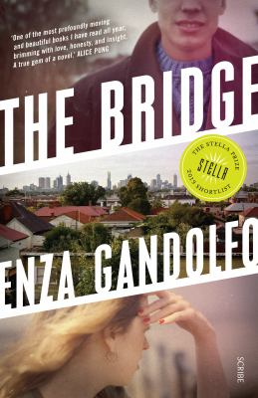
The Bridge by Enza Gandolfo

Synopsis
In 1970s Melbourne, 22-year-old Italian migrant Antonello is newly married and working as a rigger on the West Gate Bridge, a gleaming monument to a modern city. When the bridge collapses one October morning, killing 35 of his workmates, his world crashes down on him.
In 2009, Jo and her best friend, Ashleigh, are on the verge of finishing high school and flush with the possibilities for their future. But one terrible mistake sets Jo’s life on a radically different course.
Drawing on true events of Australia’s worst industrial accident — a tragedy that still scars the city — The Bridge is a profoundly moving novel that examines class, guilt, and moral culpability.

Discussion questions
- The setting of The Bridge is Yarraville, in the 1970s it was a working class suburb in Melbourne’s western suburbs. By 2009, it has been gentrified. Some of the working class characters in the novel see this gentrification as having a negative impact, they feel displaced. Do you think class is still an issue in Australia? How do you feel class impacts on your identity?
- Mandy says she has fallen out of love with her daughter. Is this believable? What do you think it would be like to be the mother of a drunk driver who is responsible for another person’s death?
- Both the collapse of the West Gate Bridge and Jo’s crash are described as ‘accidents’. Both are a result of negligent behavior. How should we as a society deal with these accidents?
- In the novel characters feel guilt for what they have done, in Antonello’s case he feels guilt for what he did not do, an act of omission (some would say this is very Catholic). Until you can forgive yourself can there ever be forgiveness or a future let alone any sense of redemption?
- One of the themes of the novel is culpability – that is the extent a person, can be held morally or legally responsible for action and inaction. Some of the things that happen to the characters are a result of their own actions/inactions and choices; other things are outside of their control. How do different characters deal with questions of culpability?
- Bad things happen to good people. Jo is not a bad person but her negligent behavior has lead to the death of another person. Does Jo deserve to remake her life?
- What do you imagine happens following the end of the novel? What do you think the future holds for Jo once she leaves prison? Will she ever fully recover?
- Who was your favourite/the most empathetic character, why? What did you like or dislike about the characters? What are the strengths of Antonello and Jo? What are the weaknesses?

Discussion questions from https://scribepublications.com.au/books-authors/books/the-bridge-9781925713015

