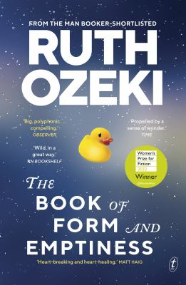
The Book of Form and Emptiness by Ruth Ozeki

Synopsis
After his father dies, Benny Oh finds he can hear objects talking: teapots, marbles and sharpened pencils, babbling in anger or distress. His mother, struggling to support their household alone, starts collecting things to give her comfort. Overwhelmed by the clamour of all the stuff, Benny seeks refuge in the beautiful silence of the public library.
There, the objects speak only in whispers. There, he meets a homeless poet and a mesmerising young performance artist. There, a book reaches out to him. Not just any book: his own book. And a very important conversation begins.
The Book of Form and Emptiness is about grief, resilience, creativity and psychological difference. It is about the importance of reading, and an observation of the mess consumer culture has got us into. It is an affirmation of the power of community. It is funny, kind, wise, urgent and completely irresistible. If you let it—if you listen—it could change your life.

Discussion questions
- The Book of Form and Emptiness is, in many ways, the coming-of-age story of a boy grappling with his own mind, his own creativity, and his own perplexing experiences, at a moment of profound loss. The Book is narrating Benny’s life, and sometimes Benny intervenes to challenge or correct or complain. What do you make of the relationship between Benny and his Book? Do you think the Book is creating Benny, or is Benny creating the Book? Which came first, the chicken or the egg?
- This is a book about books. What is your relationship to books and how have they shaped your life? How do you think hearing the Bottleman’s account of Benjamin’s life and death affected Benny?
- The Library is a very important place for Benny and for the wider community, a place where people go to both find and lose themselves, and where objects both behave themselves and come to life. What are the components that make an ideal library? How do Benny’s experiences in the library—particularly in the Bindery—alter the course of his life?
- Research has shown that between 4-10 percent of the population has at least occasionally had some kind of experience hearing voices, and many people who hear voices regularly find them to be a source of inspiration rather than a symptom or problem. And even people like Benny, who start to hear voices after some kind of traumatic experience— like the death of someone close to them—find that their voices, if properly understood, can offer insights into their experiences. Has reading about Benny’s voice-hearing experiences changed the way you view the mind? The imagination? Madness?
- If you have read Ozeki’s other novels, would you connect any of the characters from those books to the characters in this one? What themes do you notice running through her work?

Discussion questions from https://www.textpublishing.com.au/books/the-book-of-form-and-emptiness

