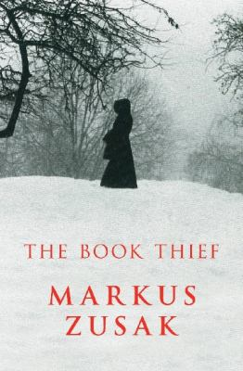
The Book Thief by Markus Zusak

Synopsis
It is 1939. Nazi Germany. The country is holding its breath. Death has never been busier, and will become busier still.
By her brother's graveside, Liesel's life is changed when she picks up an object, partially hidden in the snow. It is The Gravedigger's Handbook, and it is her first act of book thievery. So begins a love affair with books and words, as Liesel learns to read. Soon she is stealing books from Nazi book-burnings, the mayor's wife's library, wherever there are books to be found.
But these are dangerous times. When Liesel's foster family hides a Jewish fist-fighter in their basement, Liesel's world is both opened up, and closed down.

Discussion questions
- Rosa Hubermann seems unlovable (p 35) and yet she has a lot of love to give, and ‘was a good woman for a crisis.’ (p 230) Are seemingly angry people simply protecting themselves from the hurt which inevitably lies in human relationships? Discuss.
- ‘I guess humans like to watch a little destruction. Sandcastles, houses of cards, that’s where they begin. Their great skill is their capacity to escalate.’ (p 118) The novel describes Rudy Steiner: ‘he would be a giver of bread, not a stealer – proof again of the contradictory human being. So much good, so much evil. Just add water.’ (p 178) Is the capacity for violence a nasty streak in all of us?
- Music, in the form of Liesel’s papa’s accordion, is like words, symbolic here of spiritual strength. Reading this book might remind you of how other popular cultural forms such as film are often resonant with similar ideas. E.g. The movie ‘The Sound of Music’ is now almost a cliché but watching it invariably reminds you of the power of music to transcend undercurrents of fear and to symbolise hope and unity. Discuss.
- Punishment for a moral transgression must always be made personal for people to really fear it. Hans warns Liesel not to reveal that they are harboring a Jew, by threatening to take those things which are most precious to her. (pp 219-221) This is a metaphor for the need to always ‘feel’ the consequences of a crime … to ‘feel’ other people’s pain. Is our affluent society insensitive to other cultures and their pain?
- ‘What great malice there could be in allowing something to live.’ (p 270) Is the fear of death the worst thing we can endure?
- Max’s story suggests that Hitler’s power lay in the words he planted. Compare this to the rhetoric used by governments today. Are we equally manipulated by ‘the powers that be’? Discuss.
- The Book Thief has now been made into a major motion picture by Twentieth Century Fox. How does seeing the film, either before or after reading the book, impact on the reading experience?
Synopsis/Discussion questions from https://www.panmacmillan.com.au/9781742624068/

