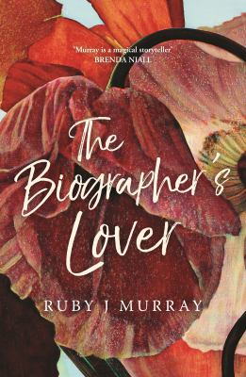
The Biographer’s Lover by Ruby J. Murray

Synopsis
Why has no one heard of Edna Cranmer?
When a young writer is hired to put together the life of an unknown artist from Geelong, of all places, she thinks it will be just another quick commission paid for by a rich, grieving family obsessed with their own past.
But Edna Cranmer was not a privileged housewife with a paintbrush. Edna’s work spans decades. Her soaring images of red dirt, close interiors and distant jungles have the potential to change the way the nation views itself.
Edna could have been an official war artist. Did she choose to hide herself away? Or were there people who didn’t want her to be famous? As the biographer is pulled into Edna’s life, she is confronted with the fact that how she tells Edna's past will affect her own future.

Discussion questions
- The structure of the book moves back and forth from the biography, in third person, to the biographer, in first person. Why do you think the author used this technique?
- Edna’s works are described vividly by the author all throughout the book so that we can imagine them in our mind’s eye. Did your image of the paintings of the house at number 27 change when the significance of the address became clear? How?
- When we are first introduced to Percy through the eyes of the biographer, we are presented with her memory of him in high school, where he rescues her from a sexual assault. What do you think of this idea of Percy as the hero? Does he live up to the hero status as the story unfolds?
- Do you think the public has a right to know about the personal lives of public figures?
- Thinking about biographies that you have read, what were the elements of the subject’s life that were most interesting? Do you think the gender of the biographer affects the story? (i.e. how might a woman write the life of a woman differently to the way a man might do so?)
- From the poem at the outset, and throughout the book, we are presented with representations of Geelong. Discuss how Geelong is described in the book, and what it tells us about the biographer, and perhaps even the author.
- On page 172 the biographer writes, ‘The reburial would mark the beginning of the carnival of commemoration — it would give Australia a heart, they said. Crumbling memorials would be rebuilt; planes sent screaming overhead; Australian flags printed by the shipload in China.’ Whenever we document history, we are re-writing it. How is war, and the remembrance of it, presented in the book? How has the Anzac myth changed over time?
- Are there Australian artists, writers, or public figures you think should be re-written or rediscovered? If so, who, and why?

Discussion questions from https://www.blackincbooks.com.au/books/biographers-lover

