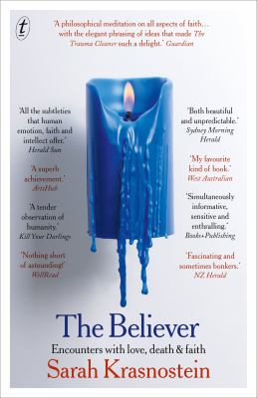
The Believer by Sarah Krasnostein

Synopsis
From award-winning author Sarah Krasnostein comes an exploration of the power of belief. Weaving together the stories of six extraordinary ordinary people, The Believer looks at the stories we tell ourselves to deal with the distance between the world as it is, and the world as we’d like it to be. How they can stunt us – or save us.
Some of the people you will meet believe in things most people don’t. Ghosts. UFOs. Heaven and the Devil. The literal creation of the universe in six days.
Others believe in things most people would like to. Dying with autonomy. Facing one’s own transgressions with an open heart.
In this intensely personal and gorgeously written new book, Krasnostein talks with her characteristic compassion and empathy to these believers – and finds out what happens when their beliefs crash into her own.

Discussion questions
- Out of all the communities and people Sarah Krasnostein spends time with and writes about in The Believer, which did you enjoy reading about most?
- In the prologue, Sarah Krasnostein writes ‘One of the lies writers tell themselves is that all things should be understood.’ Reading about the lives and experiences of people who are unlike ourselves can make us see the world differently. Has this book changed your view on any truths you held before reading? If so, in what way?
- Annie, the death doula, spends her days supporting, comforting and creating safe spaces for people who are close to death. Death is a topic that makes most people uncomfortable to discuss and plan for. Why do you think this is? Did Annie’s story make you think we could do better in handling loss and grief?
- Have you ever experienced paranormal activity? If so, share a story with your group. If you’re a sceptic, how did you respond to Vlad’s story and Sarah Krasnostein’s experience while spending time in the paranormal community?
- As a society, do you think we judge people too harshly when they hold unorthodox beliefs? What can we learn from The Believer about our attitude to people who hold beliefs different from our own?
- ‘This is why we must look again at anyone too perfectly characterised in its stories—too neatly one way, and never the other. They are not people, they are characters.’ (p. 217) What’s the difference between a person and a character?
- At the end of the book, Sarah Krasnostein writes that she believes we are united in the emotions that drive us into the beliefs that separate us. How do the very different stories in the book provide examples of people experiencing similar emotions?
Discussion questions from https://www.textpublishing.com.au/books/the-believer

