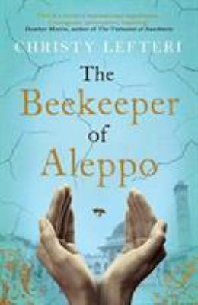
The Beekeeper of Aleppo by Christy Lefteri

Synopsis
Nuri is a beekeeper and Afra, his wife, is an artist. Mornings, Nuri rises early to hear the call to prayer before driving to his hives in the countryside.
On weekends, Afra sells her colorful landscape paintings at the open-air market. They live a simple life, rich in family and friends, in the hills of the beautiful Syrian city of Aleppo—until the unthinkable happens.
When all they love is destroyed by war, Nuri knows they have no choice except to leave their home. But escaping Syria will be no easy task: Afra has lost her sight, leaving Nuri to navigate her grief as well as a perilous journey through Turkey and Greece toward an uncertain future in Britain.
Nuri is sustained only by the knowledge that waiting for them is his cousin Mustafa, who has started an apiary in Yorkshire and is teaching fellow refugees beekeeping. As Nuri and Afra travel through a broken world, they must confront not only the pain of their own unspeakable loss but dangers that would overwhelm even the bravest souls. Above all, they must make the difficult journey back to each other, a path once so familiar yet rendered foreign by the heartache of displacement.

Discussion questions
- What kind of life did Nuri and Afra have as a family in Aleppo. Can you imagine having your life destroyed in front of your eyes and being forced to leave it all behind as Nuri and Afra did?
- Talk about the hardships of the couple's journey across Europe, on their way to Great Britain. Discuss the hatred and prejudice they endured, as well as physical dangers. What horrified you most in that journey?
- The trauma of their journey has left both Nuri and Afra deeply scarred. Talk about the way it has opened a seemingly unbridgeable gulf between the couple. Nuri is our narrator and thinks of Afra as "locked in." What in Afra's behavior leads to Nuri's assessment? How is Nuri affected? He believes he no longer worthy of her or her forgiveness. Why does believe that?
- Can you imagine what life would be like for this couple and the millions of others, who are waiting in limbo, neither able to move forward with their lives nor return the life behind them. Talk about what the limbo and dislocation would feel like. How well do you think Christy Lefteri has captured those feelings and experiences? Has reading the Beekeeper of Aleppo, led you to a different understanding, a deeper empathy perhaps, regarding refugees? Or is the problem so vast, so painful, that it remains almost impossible, as a single individual, to grasp?
- Does this book offer hope?

Synopsis/Discussion questions from https://www.litlovers.com/reading-guides/13-reading-guides/fiction/11691-beekeeper-of-aleppo-lefteri?showall=1

