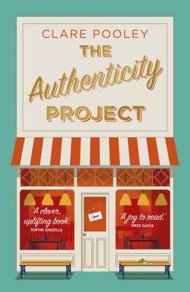
The Authenticity Project by Clare Pooley

Synopsis
Six strangers with one thing in common: their lives aren't always what they make them out to be.
What would happen if they told the truth instead?
Julian Jessop is tired of hiding the deep loneliness he feels. So he begins The Authenticity Project - a small green notebook containing the truth about his life.
Leaving the notebook on a table in his friendly neighbourhood café, Julian never expects Monica, the owner, to track him down after finding it. Or that she'll be inspired to write down her own story.
Little do they realize that such small acts of honesty hold the power to impact all those who discover the notebook and change their lives completely.

Discussion questions
- Julian calls his notebook The Authenticity Project. Do you think people are increasingly searching for authenticity in today’s world, and if so, why?
- Julian writes: 'Everyone lies about their lives'. Is this true? Do you?
- The book’s epigraph is a Leonard Cohen quote: 'There is a crack in everything. That’s how the light gets in.' What do you think these lines mean, and how are they relevant to The Authenticity Project?
- We are all connected via huge social media communities, but are we really missing the type of local, ‘IRL’ community provided by Monica’s Café and Julian’s Supper Club? What could these communities give us that virtual ones do not?
- Most of the characters in the book are lonely, but in very different ways. What are the various forms of loneliness explored in The Authenticity Project?
- The story is told from the perspectives of six main characters. Which of these did you associate with the most, and why? Which character is least like yourself?
- Baz keeps the truth from his granny in order to spare her feelings. Julian avoids the truth to protect himself. Are there times when admitting the truth isn’t the right thing to do?
- There is a scene in the book where Monica and Alice first see each other through the café window, and both want what the other has. What does The Authenticity Project teach us about envy?
- Riley is the only character in the novel who doesn’t have an obvious fatal flaw. Does this make him more loveable, or less? How does Riley act as a touchstone for the other characters?
- If you found The Authenticity Project notebook, what truth would you tell?
Discussion questions from https://www.penguin.com.au/book-clubs/2526-the-authenticity-project-book-club-notes

