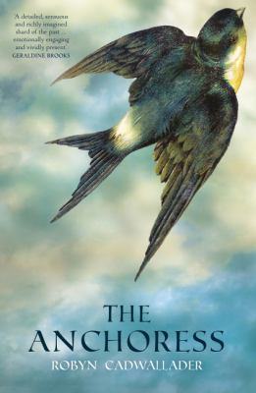
The Anchoress by Robyn Cadwallader

Synopsis
Set in England in 1255, Robyn Cadwallader’s The Anchoress is a startling and strange debut novel about a young girl’s desperate choice to isolate herself from the world. Sarah is only seventeen when she chooses to become an anchoress, a holy woman much like the one who taught Saint Hildegard of Bingen, shut away in a small cell, measuring seven by nine paces, at the side of the village church.
Fleeing the grief of losing a much-loved sister in childbirth as well as pressure to marry, she decides to renounce the world—with all its dangers, desires, and temptations—and commit herself to a life of prayer. But it soon becomes clear that even the thick, unforgiving walls of Sarah’s cell cannot keep the outside world away, and her body and soul are still in great danger.

Discussion questions
- Why did Sarah decide to be enclosed as an anchoress? Her reasons may be multiple.
- As a child, Sarah longed to fly like Swallow, the jongleur. What use does the story make of the symbol of birds and flying?
- Words and stories are important in this book, but each character has a slightly different relationship to them. How do Sarah, Ranaulf, Anna, Avice, and Eleanor relate to words and stories?
- Do you think Sarah should have told Anna that she knew Thomas raped her?
- The word “holy” is from the Old English hālig, meaning “that which must be preserved whole or intact,” and is connected with the Old English word hāl, meaning health and wholeness. In current usage it is a word layered with expectations: love of God, niceness, meekness, obedience, piety, and so on. Sarah hopes and prays that she will become holy. Does she? If she does, in what ways?
- The Rule that Sarah follows emphasizes the dangers of the eyes above all of the senses. Think about the significance of sight in the novel. What role does it play? Keep in mind both Sarah and Ranaulf, but also the people in the village.
- Sarah describes Father Peter’s gentle care and contrasts it with Father Ranaulf’s stern silences, yet she says she has learned from the spaces between Ranaulf’s words. What does she mean? Does Peter’s care limit her growth in any way? (He says, “You must learn humility, child. Think of it as submission to me, the man you are sworn to obey.”)
- How do you think the fire started? Why?
- The novel is set more than seven hundred years ago; does it have any relevance to women today? How?
Synopsis/Discussion questions from https://us.macmillan.com/books/9781250094674/theanchoress

