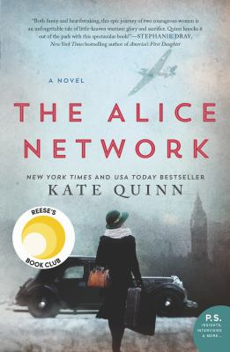
The Alice Network by Kate Quinn

Synopsis
1947. In the chaotic aftermath of World War II, American college girl Charlie St. Clair is pregnant, unmarried, and on the verge of being thrown out of her very proper family. She's also nursing a desperate hope that her beloved cousin Rose, who disappeared in Nazi-occupied France during the war, might still be alive. So when Charlie's parents banish her to Europe to have her "little problem" taken care of, Charlie breaks free and heads to London, determined to find out what happened to the cousin she loves like a sister.
1915. A year into the Great War, Eve Gardiner burns to join the fight against the Germans and unexpectedly gets her chance when she's recruited to work as a spy. Sent into enemy-occupied France, she's trained by the mesmerizing Lili, the "Queen of Spies," who manages a vast network of secret agents right under the enemy's nose.
Thirty years later, haunted by the betrayal that ultimately tore apart the Alice Network, Eve spends her days drunk and secluded in her crumbling London house. Until a young American barges in uttering a name Eve hasn't heard in decades, and launches them both on a mission to find the truth...no matter where it leads.

Discussion questions
- The young Eve introduced in 1915 is very different from the older Eve seen through Charlie’s eyes in 1947. How and when did you see the young Eve begin to change into her older self?
- Lili tells Eve, “To tell the truth, much of this special work we do is quite boring.” Did the realities of spy work surprise you, compared to the more glamorous version presented by Hollywood? How do you think you would have fared working for the historical Alice Network?
- Eve loves Captain Cameron and hates René Bordelon --- but her relationship with René is longer, darker and more complex. How is her hatred for him complicated by intimacy? How does his realization of Eve’s true identity change him? How do you think they continued to think and feel about each other during their 30 years’ separation, and how did that affect their eventual climax?
- The disappearance of Charlie’s cousin Rose Fournier provides the story’s driving search. Did her eventual fate surprise you? Had you ever heard of Oradour-sur-Glane?
- Charlie’s depression after losing her marine brother to suicide, Eve’s torture-induced nightmares, Finn’s concentration-camp memories and resulting anger issues, Cameron’s guilt over losing his recruits. How do they each cope with their war wounds? How do they help each other heal? How is PTSD handled in Eve’s day as compared to Charlie’s day --- and as compared to now?
- Charlie argues that René should be brought to legal justice, and Eve argues for vigilante justice. Who do you think is right? How did it affect the ending?
- “There are two kinds of flowers when it comes to women. The kind that sit safe in a beautiful vase, or the kind that survive in any conditions...even in evil.” The theme of the fleurs du mal carries from Lili to Eve. How does Eve pass it on to Charlie? When do you see Charlie becoming a fleur du mal in her own right? How has knowing Eve changed Charlie’s life, and vice versa?

Synopsis/Discussion questions from https://www.readinggroupguides.com/reviews/the-alice-network

