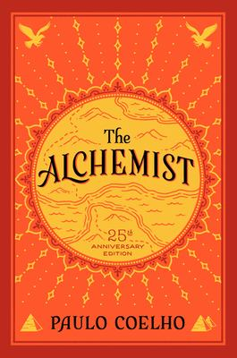
The Alchemist by Paula Coelho

Synopsis
Santiago, an Andalusian shepherd boy, has a dream about finding a treasure in the pyramids of Egypt. A gypsy woman and an old man claiming to be a mysterious king advise him to pursue it.
With the courage of an adventurer, Santiago sells his sheep and travels to Tangiers in Africa. After a thief steals his money, Santiago takes a job with a crystal merchant who unwittingly teaches Santiago important lessons for his long journey ahead. After working at the crystal shop for a year, Santiago earns enough money to cover his losses and return home. But then something unexpected happens.
On a desert caravan, Santiago meets an intriguing Englishman. The Englishman's passion for knowledge and his relentless quest to uncover the secrets of alchemy inspire Santiago to pursue his own dream of finding the treasure. As the Englishman searches for the two hundred year old alchemist who resides in the desert oasis, Santiago falls in love with a young woman, Fatima. Exposed to the greatest and eternal alchemy of all ‘love’ Santiago thinks he has found the treasure. But the greatest test of all is yet to come.
With the help of the alchemist, Santiago completes the last leg of his journey to find that the treasure he was looking for was waiting for him in the place where he least expected.

Discussion questions
- At the start of his journey, when Santiago asks a gypsy woman to interpret his dream about a treasure in the Egyptian pyramids, she asks for one tenth of the treasure in return. When Santiago asks the old man to show him the path to the treasure, the old man requests one tenth of his flock as "payment." Both payments represent a different price we have to pay to fulfill a dream; however, only one will yield a true result. Which payment represents false hope? Can you think of examples from your own life when you had to give up something to meet a goal and found the price too high?
- Paulo Coelho once said that alchemy is all about pursuing our spiritual quest in the physical world as it was given to us. It is the art of transmuting the reality into something sacred, of mixing the sacred and the profane. With this in mind, can you define your Personal Legend? At what time in your life were you first able to act on it? What was your "beginner's luck"?
- The Englishman, whom Santiago meets when he joins the caravan to the Egyptian pyramids, is searching for "a universal language, understood by everybody." What is that language? According to the Englishman, what are the parallels between reading and alchemy?
- The alchemist tells Santiago "you don't have to understand the desert: all you have to do is contemplate a simple grain of sand, and you will see in it all the marvels of creation." With this in mind, why do you think the alchemist chose to befriend Santiago, though he knew that the Englishman was the one looking for him?
- Earlier in the story, the alchemist told Santiago "when you possess great treasures within you, and try to tell others of them, seldom are you believed." At the end of the story, how did this simple lesson save Santiago's life? How did it lead him back to the treasure he was looking for?
Synopsis/Discussion questions from https://www.readinggroupguides.com/reviews/the-alchemist/guide

