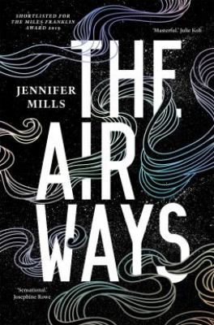
The Airways by Jennifer Mills

Synopsis
I had a body once before. I didn't always love it. I knew the skin as my limit, and there were times I longed to leave it. I knew better than to wish for this.
This is the story of Yun. It's the story of Adam. Two young people. A familiar chase. But this is not a love story. It's a story of revenge, transformation, survival.
Feel something, the body commands. Feel this.
But it's a phantom . . . I go untouched.
They want their body back.
Who are we, if we lose hold of the body? What might we become?
The Airways shifts between Sydney and Beijing, unsettling the boundaries of gender and power, consent and rage, self and other, and even life and death.

Discussion questions
- Adam is reluctant to engage with his housemates about the young woman’s murder, but we know he considers it: ‘It bruised like accusation. A random attack; these things happened. Why should he have to establish his innocence?’ (p65). Why is this? Do you think he had a role in this first murder? Or does his guilt stem from elsewhere?
- Which character do you feel holds the most power in the story? Why?
- Yun’s thirst for revenge burns slowly, as they gain assurance of who they seek. From early uncertainty, they eventually ‘want to destroy him.’ (p344), before ultimately softening when they realise all Adam can offer. Did your enjoyment of the book change as it progressed?
- When Yun, in their new form – be it a soul, spirit or ghost – returns to China, they ponder that ‘They left this country two or more transformations ago.’ (p283). What do you think they mean by this – two or more?
- The Airways is set in real cities in the modern day, however it is without mention of the global pandemic. Do you feel that, given its emphasis on breath and ongoing reference to contagion, you read this differently compared with how you might have before having any knowledge of COVID-19?
- ‘He has come all this way to put history behind him, to be relieved of his own weight. A white boy’s fantasy.’ (p344) Is Adam in Beijing merely to forget or also to atone? How important do you feel this setting is for the story?
- The ghost’s chapters are very fragmented, perhaps confusing at first. Why do you think this is? Did these chapters become clearer by the end? Did the use of language help or hinder you orientating yourself in the story?
Discussion questions from https://www.panmacmillan.com.au/9781760980504/

