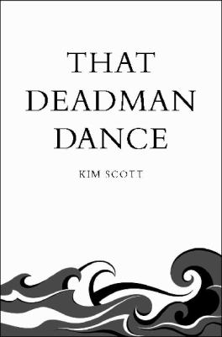
That Deadman Dance by Kim Scott

Synopsis
A crew of European settlers arrives on the coast of southwestern Australia, where the Aboriginal Noongar people have always lived. Bobby Wabalanginy is a young Noongar boy who welcomes the colonists, learns their language, and helps them with whaling and farming. A tribal storyteller and interpreter, Bobby moves easily between his people and the settlers.
Meanwhile, the ambitious but well- meaning Dr Cross befriends one of the Noongar leaders and takes Bobby under his wing. Early on, curiosity and possibility abound; however, after Cross’s death and with the arrival of more colonists, the balance of power begins to shift. Eager to welcome the colonists and learn their ways, Bobby is unaware of the dire consequences their arrival will have on the land and people.
But over time, as he witnesses more injustices, he realizes he must choose sides. With lyrical and haunting prose, the novel explores the perspectives of the Noongar people and the colonists, and examines their different ways of being and seeing. Bobby’s experiences with the settlers give readers a window into the tragedy of colonization and racism, and also offer a more hopeful view, revealing how things could have been different.

Discussion questions
- In the Prologue, Bobby Wabalanginy writes a Noongar word, Kaya, and thinks “Nobody ever writ hello or yes that way!” He then attempts to spell his name and write about the whales, “Roze a wail” (1). Why do you think the author starts with this?

- The novel includes the perspectives of many characters, including the British characters. What effect does this multiple point of view have on the narrative?
- Bobby is well- liked by the European settlers and by his own people. Describe Bobby’s personality, and find examples of his role as interpreter. How does Bobby keep the peace?
- Bobby adds movements to the Deadman Dance to make it “his own” and the other Noongar people follow his lead (62). Can you describe the dance? What is the significance of this dance? What does it reveal about the Noongars’ perceptions of the colonists? Why is it called “Deadman?”
- Bobby seemingly rises from the dead, and later touches someone and raises him from the dead, like a Christ figure. He also believes he descends from the whales. How do myth and legend shape the telling of this story?
- Betrayal is a reoccurring theme in the novel. Think of examples of where the Noongar people feel betrayed by the colonists. Do the colonists ever feel betrayed by the Noongar?
- The novel is not structured in chronological order. How does this movement between past and future affect your reading of the book? Why do you think the author chose to tell the story in this way? As the reader, you have more understanding than young Bobby does about the outcome of the settlers’ arrival. How does this impact the reading and the narrative perspective?
Synopsis/Discussion questions from https://media.bloomsbury.com/rep/files/rgg-that-deadman-dance.pdf

