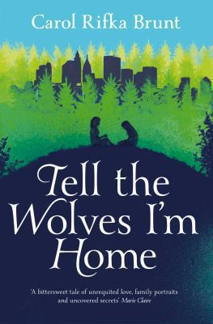
Tell the wolves I’m home by Carol Rifka Brunt

Synopsis
1987. The only person who has ever truly understood fourteen-year-old June Elbus is her uncle, the renowned painter Finn Weiss. Shy at school and distant from her older sister, June can be herself only in Finn’s company; he is her godfather, confidant, and best friend. So when he dies, far too young, of a mysterious illness her mother can barely speak about, June’s world is turned upside down.
But Finn’s death brings a surprise acquaintance into June’s life. At the funeral, June notices a strange man lingering just beyond the crowd. A few days later, she receives a package in the mail containing a beautiful teapot she recognizes from Finn’s apartment, and a note from Toby, the stranger, asking for an opportunity to meet. As the two begin to spend time together, June realizes she’s not the only one who misses Finn, and that this unexpected friend just might be the one she needs the most.

Discussion questions
- Toby initiates a relationship with June that necessarily involves secrets kept from her parents. Can this ever be right? Is it ever okay for an adult to have a secret relationship with a child, even if it’s formed out of the best of intentions?
- Every relationship in the book is tinged with jealousy and/or envy. How is this played out in each of the relationships? Can jealousy ever be a positive thing? Does loving someone too much always lead to jealousy?
- “You get into habits. Ways of being with certain people” (page 206). Toby says this to June when they’re talking about her relationship with Greta. Many sisters (and brothers) have fractious relationships as teenagers, then grow up to be friends. Do you think that will be the case with Greta and June? Have you had an experience like this with your own sibling(s)?
- If you remember the late eighties, do you remember anything about your perception of AIDS and the fear surrounding the disease?
- How has society’s reaction to homosexuality changed over the last twenty-five years? How would this story have been different if it took place in 2012?
- Do you think June will ever show Greta the secret basement room and the stash of Finn’s paintings, or will she always keep this to herself?
- Do you think the portrait was more beautiful before or after it was restored to its original state? Can a work of art be improved by external additions, or is the artist’s vision and intention the most important aspects of art?
- June would like to escape to the Middle Ages. All her favorite places are escapist in nature. Would June actually be happy if her wish of time travel were granted? How does that wish change over the course of the story? Is escapism ever valuable? How do you escape?
Discussion questions from https://www.penguinrandomhouse.com/books/214920/tell-the-wolves-im-home-by-carol-rifka-brunt/9780812982855/readers-guide/

