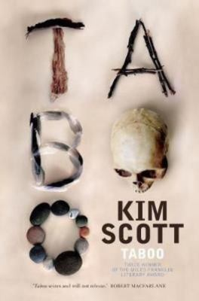
Taboo by Kim Scott

Synopsis
Taboo takes place in the present day, in the rural South-West of Western Australia, and tells the story of a group of Noongar people who revisit, for the first time in many decades, a taboo place: the site of a massacre that followed the assassination, by these Noongar's descendants, of a white man who had stolen a black woman. They come at the invitation of Dan Horton, the elderly owner of the farm on which the massacres unfolded. He hopes that by hosting the group he will satisfy his wife's dying wishes and cleanse some moral stain from the ground on which he and his family have lived for generations.
But the sins of the past will not be so easily expunged.
We walk with the ragtag group through this taboo country and note in them glimmers of re-connection with language, lore, country. We learn alongside them how countless generations of Noongar may have lived in ideal rapport with the land. This is a novel of survival and renewal, as much as destruction; and, ultimately, of hope as much as despair.

Discussion questions
- ‘It was true what people said: every old one left a hole in the world when they died, when they took language with them. That old language was a world itself, and one by one the words let you in.’ (p. 14) In what ways do you think language is crucial to a sense of cultural identity?
- How, in particular, do the spirits help Gerald and Tilly, and how important is their involvement for those two characters?
- With a white mother and a Noongar father who, until recently, Tilly has never known, and whose relationship was both destructive and violent, Tilly could be said to be a metaphor for Aboriginal and white Australia today: inextricably linked, but in conflict. What similarities are there between Tilly’s story and that of Aboriginal peoples since colonisation?
- What analogies can be drawn from the identical twin Gerrys, one newly awakened to his cultural identity and the other more closed off, more mired in the problems of many of his generation?
- ‘As they drove away from a waving Dan, Milton said, “Nice to get those stones, but if he give us the farm, that would really mean something!”’ (p. 228) In fact, Dan is indeed intending to give them the land on which the massacre occurred – at least, to Tilly, as representative of the traditional owners. Did this surprise you? If so, why, do you think?
- There is a lot of description of the natural world in this novel. How does this affect your experience of the novel, and what does it tell you about the connection between the characters and their ancestral land? How does this contrast with the manmade features that are described?
- The book is written predominantly in the third person (‘he’/’she’) and in the past tense, but with the occasional segue into the first and second person (‘I’, ‘my’, and ‘you’, ‘us’, ‘our’), and present tense. Why, do you think? What effect do these different styles have, and whose voice (or voices) are being referenced?
Discussion questions from https://www.panmacmillan.com.au/9781925483741/

