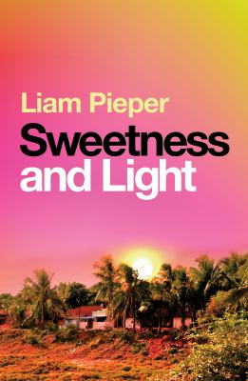
Sweetness and Light by Liam Pieper

Synopsis
India, monsoon season.
Connor, an Australian expat with a brutal past, spends his time running low-stakes scams on tourists in a sleepy beachside town. Sasha, an American in search of spiritual guidance, heads to an isolated ashram in the hope of mending a broken heart.
When one of Connor’s grifts goes horribly wrong, it sets in motion a chain of events that brings the two lost souls together – and as they try to navigate a world of gangsters, gurus and secret agendas, they begin to realise that within the ashram’s utopian community, something is deeply, deeply wrong . . .
Racing from the beaches of Goa to the streets of Delhi to the jungles of Tamil Nadu, Sweetness and Light is an intoxicating, unsettling story of the battle between light and dark, love and lust, morality and corruption. This is an explosive and unforgettable novel that confirms Liam Pieper's place as one of Australia's finest, sharpest writers.

Discussion questions
- Sasha’s mama and Connor’s dad both want the best for their children but ultimately drive them away. What elements of their upbringing can be seen in Sasha and Connor’s behaviour over the course of the novel? Does it explain the choices they make?
- The present of the novel is set in an India where the influence of Westerners is keenly felt, from tourism and spirituality to drug trafficking and medical care. What did you make of the West’s incursions into these places? What about it attracts and repels the main characters?
- Sasha and Connor both grew up in low socio-economic households. How does this compare to the lives they lead in India?
- The guru says: ‘There is no place more holy than India. There is no place more miserable. These ideas are not unrelated.’ Is she right?
- Much of the novel interrogates the boundary between appearances and reality, between surface and underbelly. With that in mind, how real is Sasha and Connor’s romance?
- By the end of the novel both Sasha and Connor have made difficult, compromised decisions. Who is more selfish? Who is the better person?

Discussion questions from https://www.penguin.com.au/book-clubs/2536-sweetness-and-light-book-club-notes

