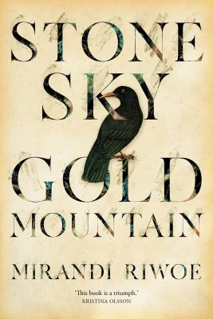
Stone Sky Gold Mountain by Mirandi Riwoe

Synopsis
Family circumstances force siblings Ying and Lai Yue to flee their home in China to seek their fortunes in Australia. Life on the gold fields is hard, and they soon abandon the diggings and head to nearby Maytown.
Once there, Lai Yue gets a job as a carrier on an overland expedition, while Ying finds work in a local store and strikes up a friendship with Meriem, a young white woman with her own troubled past. When a serious crime is committed, suspicion falls on all those who are considered outsiders.

Discussion questions

- Stone Sky Gold Mountain is set in Maytown, North Queensland, in the 1870s. Does this novel offer a different cultural portrait of a Northern Queensland township from the one generally portrayed?
- Over the course of the book, Ying and Merri become close, yet there are limitations to their relationship. How are these limitations reflected in the novel?
- Lai Yue struggles with his responsibilities as the eldest son and brother in a Chinese family. In what way does his character represent the tribulations of this position in his family?
- Place is an important aspect of this novel. Stone Sky Gold Mountain is set during the gold rush, on land largely uncharted by white Australians and the Chinese. What are some memorable descriptions in the book that situate the reader in North Queensland?
- Ying, Lai Yue and Meriem are new to the Palmer River area. In what different ways does each character respond to their surrounds?
- What is your interpretation of Shan’s role in the novel and for Lai Yue?
- Did Lai Yue’s character make you feel angry, sad, frustrated or perplexed? Why?
- Which aspects of this novel – to do with racism, immigration policy, sexism – are still contested issues in society today? Do you think the situation has improved or worsened in regard to these issues?
- Who do you think is the bravest character in Stone Sky Gold Mountain?
- Did you have a favourite scene in the book? Which one, and why?
- If things had turned out differently and Ying had not left so abruptly, what do you think her future with Merri would have looked like?
- Do you think Ying will ever return to Australia?
Discussion questions from https://www.uqp.com.au/books/stone-sky-gold-mountain

