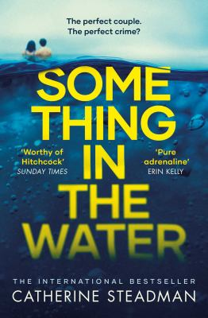
Something in the Water by Catherine Steadman

Synopsis
Erin is a documentary filmmaker on the brink of a professional breakthrough, Mark a handsome investment banker with big plans. Passionately in love, they embark on a dream honeymoon to the tropical island of Bora Bora, where they enjoy the sun, the sand, and each other. Then, while scuba diving in the crystal blue sea, they find something in the water…
Could the life of your dreams be the stuff of nightmares?
Suddenly the newlyweds must make a dangerous choice: to speak out or to protect their secret. After all, if no one else knows, who would be hurt? Their decision will trigger a devastating chain of events.
Have you ever wondered how long it takes to dig a grave?

Discussion questions
- The novel begins with the striking scene of Erin digging a grave, then flashes back in time to describe the events leading up to it. Is this an effective way to enter the story? Did the opening pages hook you? Why or why not?
- Erin’s career as a documentary filmmaker puts her in touch with incarcerated people she may never have met otherwise, and her relationship with Eddie is especially complex. She never tells Mark about him and is drawn to him during her interviews. She befriends a known criminal. Why does Erin become so closely involved with him? How genuine are her connections with her other documentary subjects, and how do those relationships affect the events in the novel?
- After their discovery on the scuba dive, how does Erin and Mark’s relationship change? Despite the secrets they’re hiding from each other, they do not struggle intimately. Do they truly love each other?
- Money is a motivating factor in Erin and Mark’s decisions, and the idea of the fiscal divide between the extremely wealthy and the middle classes percolates through the novel. Are the characters in the novel motivated by greed? Or survival? Do financial issues have the power to tear people apart?
- Erin is often very empathetic, and she doesn’t blame Mark for the consequences of their actions until she has no other choice. Does this reflect a broader tendency for partners to excuse their spouses’ behaviors or put them on a pedestal? Is that reaction even more common among women than men?
- Erin learns a striking piece of news in the closing pages of the book. Will this affect her character for the better—or for the worse? Do you think Erin is capable of committing a crime herself in the future?
- The novel ends with Erin thinking, "You can’t save everyone. Sometimes you just have to save yourself." What sacrifices does Erin have to make to save herself? Does she leave anyone behind? Would you have made the same choices?
Synopsis/Discussion questions from https://www.litlovers.com/reading-guides/13-reading-guides/fiction/11313-something-in-water-steadman?showall=1

