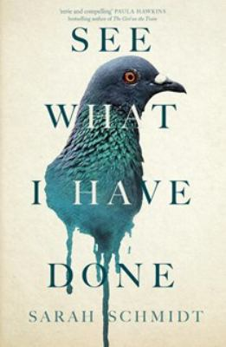
See What I Have Done by Sarah Schmidt

Synopsis
On the morning of August 4, 1892, Lizzie Borden calls out to her maid: Someone’s killed Father. The brutal ax-murder of Andrew and Abby Borden in their home in Fall River, Massachusetts, leaves little evidence and many unanswered questions.
While neighbors struggle to understand why anyone would want to harm the respected Bordens, those close to the family have a different tale to tell — of a father with an explosive temper; a spiteful stepmother; and two spinster sisters, with a bond even stronger than blood, desperate for their independence.
As the police search for clues, Emma comforts an increasingly distraught Lizzie whose memories of that morning flash in scattered fragments. Had she been in the barn or the pear arbor to escape the stifling heat of the house? When did she last speak to her stepmother? Were they really gone and would everything be better now?

Discussion questions
- How would you describe Lizzie?
- What was the family dynamic of the Borden household? Talk especially about Andrew Borden and his treatment of his daughters. Consider the sisters' strained relationship with their stepmother. How would you describe the relationship between Lizzie and Emma? What about Lizzie's remark that "None of this would have had happened if she [Emma] hadn't left me in the house."
- What were Lizzie's particular resentments regarding her father? Is there one that might have set her off?
- Talk about Bridget's position in the house.
- Schmidt blurs the voices and perceptions of characters. Did you find this confusing? Or is the blurring part of the emotional intensity that propels the novel?
- Sarah Schmidt writes with an almost sickening physicality — of odors, vomiting, dirty under garments, or bladders full to bursting. Why might she have chosen to employ such vivid descriptions? What effect does it have on the novel's atmosphere and/or tone?
- Good mysteries depend on suspended revelation, information withheld from readers. What information does Sarah Schmidt withhold? Consider hints at Lizzie's instability. What other hints, for instance, are leveled at Benjamin or Uncle John?
- Speaking of Uncle John: what is his role in all of this?
- Schmidt's novel is both a "whodunit" and a "whydunit." What makes Lizzie the prime suspect: Since she was never convicted, however, what are your thoughts on who most likely murdered the Bordens … and why?
Discussion questions from https://www.litlovers.com/reading-guides/fiction/11070-see-what-i-have-done-schmidt?start=3

