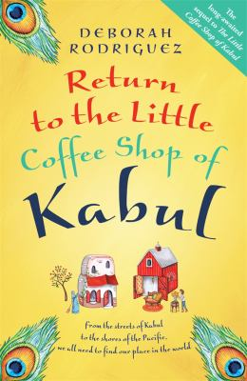
Return to the Little Coffee Shop of Kabul by Deborah Rodriguez

Synopsis
Sunny, its former proprietor and the new owner of the Screaming Peacock Vineyard in the Pacific Northwest. But can she handle the challenges of life on her own?
Yazmina, the young mother who now runs the cafe, until a terrifying event strikes at the heart of her family, and business . . .
Layla and Kat, two Afghan teenagers in America, both at war with the cultures that shaped them . . .
Zara, a young woman about to be forced into a marriage with a man she despises, with devastating consequences for all . . .
These five women are about to learn what Halajan, Yazmina’s rebellious mother-in-law, has known all along: that when the world as you know it disappears, you find a new way to survive . . .

Discussion questions
- Layla and Kat hold differing views on practically everything in Afghan culture, including the wearing of the hijab. Do you find one opinion more valid than the other, and if so, why?
- In Chapter 21, Joe states that ‘a love of country can be a very complicated thing’. In that regard, how do the struggles of the characters in this book compare with one another?
- Ahmet and his fellow students choose the issue of corruption in their country as the priority for their discussion group. How does corruption touch the lives of some of the characters in this story?
- What do you find surprising about contemporary life in Afghanistan?
- We see Ahmet struggling with his changing attitudes toward his country and its customs. What were the defining moments that caused him to shift back and forth on his views?
- What do you think really keeps Sunny from leaving the island?
- Halajan learns that a peahen costs less than a peacock. In what ways were the Afghan women thought to be worth less than men? Does it seem as though that might change?
- Did anything surprise you about Layla’s reactions to the US?
- Halajan says, ‘A girl with a book is the best weapon for progress.’ Why is that so?

Discussion questions from https://www.penguin.com.au/books/return-to-the-little-coffee-shop-of-kabul-9780857988317/book-clubs/390-return-kabul

