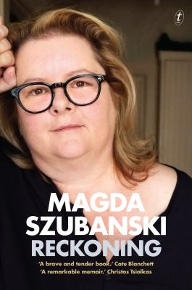
Reckoning by Magda Szubanski

Synopsis
For Magda Szubanski, her family heritage is a significant part of the answer, both from her Polish father, an assassin in the Polish resistance, and from her mother, a sharp-and-soft Scottish woman of Irish descent. Another part of the answer lies in her sexuality, first repressed and then hidden for years. There are other factors too – education, feminism, teachers, friends and mentors, career, creativity.
It is her father who looms largest in Szubanski’s emotional landscape, and she has defined herself both by and against his example and expectations. Her mother’s family also has a history of trauma, through the famines and poverty of Ireland, and the trenches of Passchendaele. At the same time as looking back to her parents’ families, she captures the family dynamics of her own life – a family where each sibling ‘carved out—or were allotted—our own turf’ (56).
As she looks inwards, she is frank about the difficulties she has experienced. And through this all, Reckoning also looks outwards: to the suburbia of her childhood, to the leftist university circles and feminist movement of the 1970s, to the Melbourne comedy scene, and to the trajectory of her career.
Reckoning ends with Szubanski reveling in the freedom of coming out, listing her father’s qualities, wishing that he had been alive to see her come out publicly, and expressing gratitude that her mother was there for her. For Magda Szubanski, the defining features of her life are intertwined to the end.

Discussion questions
- How does the Magda Szubanski revealed in this memoir match with her public persona?
- Through all the trauma and emotional difficulties, did you find moments of humour in Reckoning?
- Ultimately, Szubanski realises she is a paradoxical mix of both her parents: ‘my Irish talking-paralysis on the one side, and my Polish romantic impulsiveness on the other.’ (347). Are we inevitably a product of our parents? What is your take on the nature versus nurture debate?
- More specifically, how does trauma get passed down from parents to their children? As Szubanski asks, ‘Can it be that some dim memory of trauma is carried in our genes?’ (344).
- After passing the entrance exam to a new school, Szubanski is ‘crushed by the feeling that I was just an extension of [my father]… My life and achievements were not my own’ (119). What do we owe our parents? Do children of parents who have suffered owe them more?
- Do public figures have a duty to come out?
- Given the importance of her father and his family to Szubanski’s self-identity, why do you think it is ‘Ireland and the story of my grandfather Luke that finally cracked open the hard shell around my heart’ (336).
- Do you think this memoir is an exercise in self-exploration, or is it trying to communicate something broader about the world?
Discussion questions from https://www.textpublishing.com.au/books/reckoning

