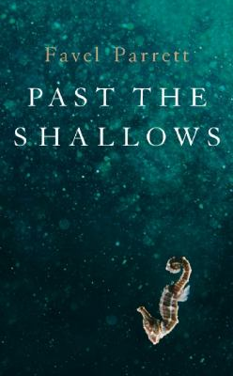
Past the Shallows by Favel Parrett

Synopsis
Joe, Miles, and Harry are growing up on the remote southern coast of Tasmania - a stark, untamed landscape swathed by crystal blue waters. The rhythm of their days is dictated by the natural world, and by their father's moods. Like the ocean he battles daily to make a living as a fisherman, he is wild and volatile - a hard drinker warped by a devastating secret.
Unlike Joe, Harry and Miles are too young to move out, and so they attempt to stay as invisible as possible whenever their father is home. Miles tries his best to watch out for Harry, but he can't be there all the time. Often alone, Harry finds joy in the small treasures he discovers by the edge of the sea - shark eggs, cuttlefish bones, and the friendship of a mysterious neighbor. But sometimes small treasures, or a brother's love, simply are not enough…

Discussion questions
- Aunty Jean is the only female role model the boys have left. She is at times cruel and caring towards them. Do you consider her a good person?
- Jeff exhibits increasingly dangerous and bullying behaviour: the staring, shooting the shark and risking hitting Miles, forcing Harry to drink. Does he bring about Dad's worst behaviour to his sons?
- Joe is also part of this family unit. Why do you think he is painted as one of the family, but also an outsider? He used to work on the boat, now doesn't. He moved to live with his grandfather. Why do you think Favel Parrett chose not to include point of view from Joe?
- Memory plays a big part in this novel. Discuss the way in which memories are invoked in Past the Shallows and what part they play in the story.
- It's obviously a point of rage for Dad. Do you have any sympathy for him? How did you feel when you learned through Joe that he'd disappeared and there would be no direct confrontation or punishment for his acts? Was this a satisfactory ending for you? Why/why not?
- Do you believe this is a utopian afterlife image from Harry after death? Or do you think this is a fragment of unconscious dreaming from Miles?
- Harry and Miles' story is bookended between the evocative phrase: 'Out past the shallows, past the sandy-bottomed bays, comes the dark water – black and cold and roaring. Rolling out the invisible paths...' What effect did the imagery and repetition have on you going into the beginning of the story? And on leaving the story?
- Although very evocative of the Tasmanian coast, do you think that the story transcends borders, and would be just as thought-provoking to a reader in another country?

Discussion questions from https://www.bookbrowse.com/reading_guides/detail/index.cfm/book_number/3049/past-the-shallows

