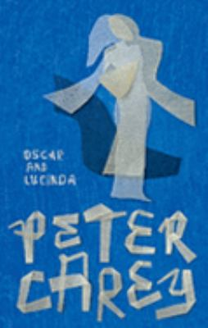
Oscar and Lucinda by Peter Carey

Synopsis
This sweeping, irrepressibly inventive novel, is a romance, but a romance of the sort that could only take place in nineteenth-century Australia. For only on that sprawling continent—a haven for misfits of both the animal and human kingdoms—could a nervous Anglican minister who gambles on the instructions of the Divine become allied with a teenaged heiress who buys a glassworks to help liberate her sex.
Only the prodigious imagination of Peter Carey could implicate Oscar and Lucinda in a narrative of love and commerce, religion and colonialism, that culminates in a half-mad expedition to transport a glass church across the Outback.

Discussion questions
- The earliest of the many arresting episodes in this book is the Christmas pudding incident. How does Oscar's delight in this new taste—and the subsequent anger of his father—set the stage for the events of the novel?
- Talk about Oscar's religious beliefs. Is he good...or corrupt? Is he endangering his soul by gambling? Or does the fact that he devotes his winnings to charitable causes justify, or make right, his gambling obsession? What does Oscar believe?
- What kind of characters are Oscar and Lucinda? They're eccentric, of course, but how else might you describe them? What makes them fall in love? (Can you recall the moment when Lucinda suddenly realizes that she might be in love with Oscar?)
- Discuss the ways Lucinda flouts prevailing societal codes for women of her day?
- In what way do Oscar and Lucinda refuse to accept their society's racist views of Australia's Aboriginals?
- Is it a flaw, or a strength, in their characters that neither Oscar nor Lucinda understands or cares how others view them?
- What affect does the use of shifting perspectives have on your reading of the novel? Did you find the varying points of view illuminating or confusing or interruptive?
- What was your experience reading this book? Did you find it humorous, sad, funny, intriguing? Talk about Carey's writing style—his descriptive passages; insinuations and indirect sentences; and satirical eye.
- Were you satisfied or disappointed by the novel's ending? Where were the plot's turning points—where different decisions by either Oscar or Lucinda might have changed the story's outcome?

Discussion questions from https://www.litlovers.com/reading-guides/fiction/714-oscar-and-lucinda-carey?start=3

