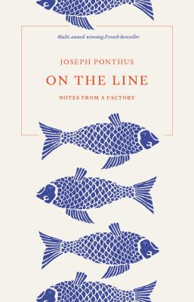
On the Line by Joseph Ponthus, Stephanie Smee

Synopsis
Unable to find work in his field, Joseph Ponthus enlists with a temp agency and starts to pick up casual shifts in the fish processing plants and abattoirs of Brittany. Day after day he records with infinite precision the nature of work on the production line: the noise, the weariness, the dreams stolen by the repetitive nature of exhausting rituals and physical suffering. But he finds solace in a life previously lived. Shelling prawns, he dreams of Alexandre Dumas. Pushing cattle carcasses, he recalls Apollinaire. And, in the grace of the blank spaces created by his insistent return to a new line of text – mirroring his continued return to the production line – we discover the woman he loves, the happiness of a Sunday, Pok Pok the dog, the smell of the sea.
In this celebrated French bestseller, translated by Stephanie Smee, Ponthus captures the mundane, the beautiful and the strange, writing with an elegance and humour that sit in poignant contrast with the blood and sweat of the factory floor. On the Line (À la ligne) is a poet’s ode to manual labour, and to the human spirit that makes it bearable.

Discussion questions
- Throughout the book, Ponthus uses almost no punctuation – the only breaks in the flow of words being line returns, capitals and section breaks: ‘I write like I think when I’m on my production line / Mind wandering alone determined / I write like I work / On the production line / Return / New line’. Discuss how this style affected you as readers.
- Ponthus calls work on a production line ‘modern slavery’. Having read his book, do you agree with this description, and why? Are there any other contemporary jobs that you would describe this way?
- Ponthus aims not to write about ‘the grimness of the factory / Rather its paradoxical beauty’. Do you feel he is successful in this?
- After working on various fish-processing lines for several months, Ponthus finds a month’s work as a ‘boss’ in the social-work sector for which he was trained. Discuss how he rates both the work and the colleagues in this role against those on the production line.
- Ponthus compares the horrors and the physical demands and dangers of the abattoir to war: ‘It’s all much of a muchness / … / The blood the blood the blood / I’m advancing now / I’ve moved on from pork to beef / Almost at the front line’. He repeatedly references French poet Apollinaire’s writings from the trenches of the First World War. How – if at all – do you think Ponthus’s analogy fits?
- Ponthus muses on what his puppy, Pok Pok, asking [what] ‘would you make of it if I were to tell you exactly / what goes on at the abattoir / Would you look at me differently / … see me as an agent of the banality of evil’. Yet his workmates are ‘Patient and resolute’, ‘good guys’; even the ‘slaughterers’ ‘… look no worse nor better than me’, and ‘Perhaps / … / Some of them too have a dog they love’. Ponthus reveals how our choices as consumers dictate the need for unpleasant tasks to be carried out by people no different from ourselves, and suffering to be inflicted on animals. Do you think that reading this book will affect your consumer choices and decisions? If yes, how?

Discussion questions from https://www.blackincbooks.com.au/books/line

