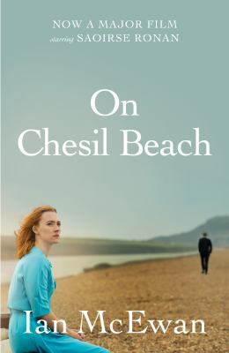
On Chesil Beach by Ian McEwan

Synopsis
Very much in love, Edward and Florence are predictably nervous, but for different reasons.
He longs to consummate the marriage; she is repelled by the very idea. Locked in their inhibitions and utterly unable to discuss their fears and needs, they are victims not only of personal experience but of a distinctively British brand of repression destined to crumble in the sexual revolution.
One of McEwan's greatest skills is his ability to limn the precise, irrevocable moment in which life changes forever.
And although that moment is telegraphed within the first few pages of this rueful tale, it loses none of its tragic, devastating force when it occurs.

Discussion questions
- What do the novel’s opening lines tell us about Edward and Florence? How did your perceptions of them change throughout the subsequent pages? What details did you eventually know about them that they never fully revealed to one another?
- Is Edward’s libido truly the primary reason he proposes marriage, or were other factors involved (perhaps ones he did not even admit to himself)? Are relationships harmed or helped by cultural restrictions against sex before marriage?
- Were Florence and Edward incompatible in ways beyond sexual ones? What do their difficulties in bed say about their relationship altogether? Or is sex an isolated aspect of a marriage?
- What did Edward’s decision to go to London for college indicate about his goals? What was Florence’s dream for her future? Was marriage a greater social necessity for her, as a woman?
- To what extent was the financial gulf between Edward and Florence a source of trouble? How might the relationship have unfolded, particularly during this time period, if Edward, not Florence, had been the spouse with financial security?
- Discuss the novel’s setting, which forms its title. What is the effect of the creaky hotel McEwan creates, and the crashing permanent waves on a beach where the temperatures are still chilly in June? What does it say about the newlyweds that this is the scene of their wedding night?
- The author tells us that the marriage ended because Edward was callous, and that as Florence ran from him, she was at the same time desperately in love with him. Why did Edward respond the way he did? Why was it so difficult for them to be honest about their feelings? How would you have reacted that night?
- Discuss the structure of On Chesil Beach . What is the effect of reading such a compressed storyline, weaving one night with the years before and after it? How did it shape your reading to see only Edward’s point of view in the end? What might Florence’s perspective have looked like?
Discussion questions from https://www.litlovers.com/reading-guides/13-reading-guides/fiction/699-on-chesil-beach-mcewan?showall=1

