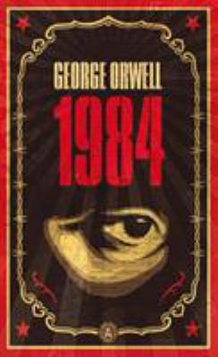
Nineteen Eighty-Four by George Orwell

Synopsis
Winston Smith toes the Party line, rewriting history to satisfy the demands of the Ministry of Truth. With each lie he writes, Winston grows to hate the Party that seeks power for its own sake and persecutes those who dare to commit thought crimes. But as he starts to think for himself, Winston can’t escape the fact that Big Brother is always watching…
A startling and haunting vision of the world, 1984 is so powerful that it is completely convincing from start to finish. No one can deny the influence of this novel, its hold on the imaginations of multiple generations of readers, or the resiliency of its admonitions—a legacy that seems only to grow with the passage of time.

Discussion questions
- In the afterword, the commentator describes 1984 as “a warning.” Indeed, throughout the text, Orwell plants both subtle and overt warnings to the reader. What do you think are some of the larger issues at hand here?
- Discuss Winston as a heroic figure. What qualities does he possess that could define him as one?
- Compare and contrast some of the other characters in Winston’s world: Parsons, Syme, O’Brien. How does Winston view each one? How do they differ from Winston?
- From her first appearance as “the dark-haired girl,” through to the end of the novel, Julia is a key figure in 1984. Trace the path of Julia in relation to Winston’s life; in what ways does she influence him? Did you trust her, initially? Overall, do you feel she had a positive or negative impact upon him?
- How would you describe the author’s tone in 1984? Does it add to or detract from the character’s discourse?
- Discuss the role of sex and intimacy in 1984. What specific function does the Party’s directive on sexual interaction serve?
- In the final analysis, how accurate was Orwell in his vision of the future? In what ways does our contemporary society compare to his idea of society in 1984? Are there examples in which he was correct? What is most opposite? Do you see a potential for aspects of Orwell’s “vision” to come true?
- During his final encounter with O’Brien, Winston argues that, if all else fails, the inherent nature of the individual-the “spirit of man”-is strong enough to undermine a society such as that created by The Party. Do you agree or disagree with this statement? Is Winston’s belief applicable to the world we live in today?
- Imagine yourself as Winston Smith at the beginning of 1984. What would you do to undermine The Party? Knowing what you know now, how would you extricate yourself from the fate that awaits you?

Discussion questions from https://www.penguinrandomhouse.com/books/326569/1984-by-george-orwell-with-a-foreword-by-thomas-pynchon/9780452284234/readers-guide/

