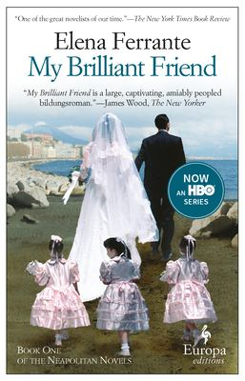
My Brilliant Friend by Elena Ferrante.
Translated by Ann Goldstein

Synopsis
From one of Italy’s most acclaimed authors, comes this ravishing and generous-hearted novel about a friendship that lasts a lifetime. The story of Elena and Lila begins in the 1950s in a poor but vibrant neighborhood on the outskirts of Naples. Growing up on these tough streets the two girls learn to rely on each other ahead of anyone or anything else, as their friendship, beautifully and meticulously rendered, becomes a not always perfect shelter from hardship. Ferrante has created a memorable portrait of two women, but MY BRILLIANT FRIEND is also the story of a nation. Through the lives of Elena and Lila, Ferrante gives her readers the story of a neighborhood, a city, and a country undergoing momentous change.

Discussion questions
- Why is Don Achille such an important character? His presence looms over the whole novel; what does he represent?
- Throughout the novel, Lila earns her reputation as “the misfit,” while Elena comes to be known as “the good girl.” How do the two live vicariously through one another, and what is it about their differing personalities that make their relationship credible? Which girl, if any, do you most easily identify with?
- Domestic life in the outskirts of Naples in the 1950s is depicted as conservative, challenging and, at times, even severely violent. Ferrante uses the girls’ early “child play” to emulate the callous undertones of the town. Why is this analogy so successful? What is so important about Tina and Nu?
- Why is Elena so invested in her education? Is it a means to an end, or an end unto itself? If a means to an end, what end? And if a means, is she being realistic or is she fooling herself?
- What is revealed of the girls’ characters on the day they decide to skip school? Do these discoveries surprise you? How does this effect their relationship (or our sense of their relationship)?
- It can be assumed that Elena’s voice is behind the title of the novel, referring to Lila as “her brilliant friend.” However, toward the end of the girls’ story, it is Lila who praises Elena, and encourages her to be “the best of all, boys and girls” (pg. 312). Is this dialogue between the two girls symbolic of Lila’s surrender? Are you surprised by Lila’s words?
- What do the shoes that Lila designs and makes represent symbolically? What undertones do the shoes help to evidence in the latter half of the novel?
- How would the book be different if told from the point of view of Lila or another character? Is Elena's point of view the most appropriate?
Discussion questions from https://www.readinggroupguides.com/reviews/my-brilliant-friend/guide

