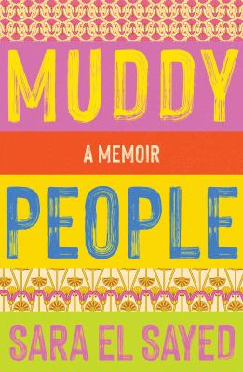
Muddy People by Sara El Sayed

Synopsis
Soos is coming of age in a household with a lot of rules. No bikinis, despite the Queensland heat. No boys, unless he’s Muslim. And no life insurance, not even when her father gets cancer.
Soos is trying to balance her parents’ strict decrees with having friendships, crushes and the freedom to develop her own values. With each rule Soos comes up against, she is forced to choose between doing what her parents say is right and following her instincts. When her family falls apart, she comes to see her parents as flawed, their morals based on a muddy logic. But she will also learn that they are her strongest defenders.

Discussion questions
- How does the book’s structure lead you through the story? Did you find the way the chapters were broken up helpful in following the timeline?
- The book juxtaposes a strict Egyptian Muslim family with a more easygoing Australian lifestyle. In what ways are they different, and in what ways are they (perhaps surprisingly) the same?
- ‘Men are pigs, all of them. Don’t get married, if you can help it.’ (p.57) Nana doesn’t have a good opinion of men. How do Nana’s life experiences influence the author and her mother? How does family history shape younger generations?
- The author talks about wanting to be a good person and wanting to make Baba happy. There are lots of references throughout the book to religious ideas of what is good and bad. Discuss how religion plays a part in morality and how overarching themes of good versus evil appear in different cultures.
- The author takes the blame for her parents’ divorce in the hope that it will spare them some burden. Discuss the themes of guilt, blame and sacrifice in familial relationships.
- When the author is made school captain she wonders if it is because she used humour to give the other students a ‘racism hall pass’ (p.198). Self-deprecating humour is often used to make people feel at ease – particularly when it comes to race, sexuality and disability. Can you think of entertainers who use self-deprecating humour and why they might do so?
- When the author’s brother, Mohamed, brings a white girlfriend home and their father has no issue with this, the author is angry. Why? Why are the rules different for her? What does she do about this?
- Muddy People is – among other things – a migrant story. Have you read other memoirs that are similar to this? In what ways were they similar?
- What are your lasting impressions of the book? How did it make you feel, and were you surprised by the last chapter?
Discussion questions from https://www.blackincbooks.com.au/books/muddy-people

