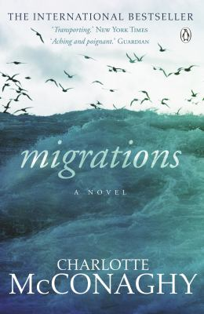
Migrations by Charlotte McConaghy

Synopsis
Franny Stone has always been a wanderer. By following the ocean’s tides and the birds that soar above, she can forget the losses that have haunted her life.
But when the wild she loves begins to disappear, Franny can no longer wander without a destination.
She arrives in remote Greenland with one purpose: to find the world’s last flock of Arctic terns and track their final migration. She convinces Ennis Malone, captain of the Saghani, to take her onboard, winning over his eccentric crew with promises that the birds will lead them to fish. As the Saghani fights its way south, Franny’s dark history begins to unspool. Battered by night terrors, accumulating a pile of unsent letters, and obsessed with pursuing the terns at any cost, Franny is full of secrets.
When her quest threatens the safety of the entire crew, Franny must ask herself what she is really running toward—and running from.

Discussion questions
- Discuss the novel’s first lines: "The animals are dying. Soon we will be alone here." How does the disappearance of wildlife in mass extinctions shape the characters and plot? What are the similarities and differences between Franny’s world and our own?
- Arctic terns have the longest natural migration of any animal, and during their lives they may travel the equivalent distance of to the moon and back three times. What do Arctic terns symbolize in the novel, and why are Franny and Niall so drawn to them in particular?
- What does Ireland represent for Franny? Australia? Discuss the importance of home and belonging in this novel, and how Franny’s search for it shapes her life.
- Franny says: "It isn’t fair to be the kind of creature who is able to love but unable to stay." Why does she have so much trouble staying, even with the people she most loves? Did you find that aspect of her character sympathetic?
- In his lecture, Niall says of wildlife: "They are being violently and indiscriminately slaughtered by our indifference. It has been decided by our leaders that economic growth is more important." How does that resonate in our world, as leaders debate the appropriate response to climate change?
- Ennis tells Franny about Point Nemo, "the remotest place in the world, farther from land than anywhere else." When she asks what it’s like, he replies, "There’s nowhere crueler or lonelier…. It’s quiet." Why are Ennis and Franny so drawn to Point Nemo?
- Why does Franny take responsibility for the deaths of Niall and Greta? Do you think she is right to blame herself and plead guilty?
- What does Franny hope to accomplish by following the terns on their last migration? What about Ennis? What do you think the future holds for them?

Discussion questions from https://www.penguin.com.au/book-clubs/2740-the-last-migration-book-club-notes

