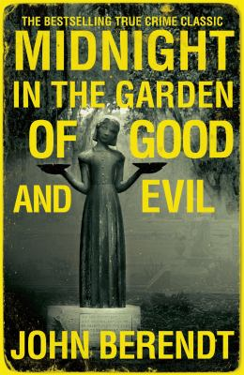
Midnight in the Garden of Good and Evil by John Berendt

Synopsis
The victim is Danny Hansford, a small-time hustler who, early on a Saturday morning in May 1981, was shot dead by his sometime employer Jim Williams in the latter's exquisitely restored house in Savannah, Georgia. As Berendt reconstructs Danny's death--and follows Williams's staggering four murder trials--he also presents us with a lovingly detailed social anthropology of Savannah, whose past is full of murders that have been covered up and cheerfully gossiped about for decades afterwards. The author keeps a discreet distance from his protagonists. His true object is to see how a crime engages the collective imagination of a city to shake them out of their usual preoccupations.
Berendt himself becomes one of the book's characters, an ingenuous expatriate Yankee who, in the process of making himself at home in Savannah, manages to go everywhere, meet everyone, and ferret out every morsel of the city's delicious gossip--except, perhaps, the truth behind Danny Hansford's death.

Discussion questions
- Do you come away from this book believing that Williams is guilty of murder? How does the evidence that surfaces during his trials reinforce or contradict the impression that Berendt conveys elsewhere in the book? How do Williams's friends view him?
- It becomes clear that Savannah is full of mysterious characters, from the man with the invisible dog to the salesman who makes up his left eye with purple eyeshadow while leaving the other unadorned for the benefit of his boss. How much do we end up knowing about the people in this book?
- Do you think of Chablis as male or female? Why has she chosen not to undergo sex-change surgery? By what logic can she say that her boyfriend--who knows her true gender--is "straight" [p. 102]? What vision of gender does this book impart to us?
- Although Williams behaves as though he were innocent of any wrongdoing, he also goes to elaborate lengths to conceal the fact of his imprisonment from his clients. How do you account for this? In what ways are the contradictions in his conduct typical of his city?
- The "Garden of Good and Evil" is Bonaventure cemetery, which the author visits at the book's beginning and end. What role do the dead play in Berendt's narrative? How do they influence its action and haunt the living characters?
- Frustrated by his attorneys' failure to win an acquittal, Williams hires a conjure woman to work on his behalf. How successful are Minerva's efforts compared to those of more conventional specialists?
- How do we end up feeling about the character of "John Berendt"? What does the author accomplish by making himself a character in his book--or, rather, by creating a character who happens to have his name and profession?
Discussion questions from https://www.readinggroupguides.com/reviews/midnight-in-the-garden-of-good-and-evil/guide

